|  |  |
| --- | --- |
| Ref No: | CABS/06/61/TRI/011 |
| Type: |  |
| Date: | 22/05/2021 |
| Copy No: |  |
| No. of Pages: | 60 |

**Title: Applied Generative Adversarial Networks for SAR, EO/IR and Sensor Image Exploitation.**

**College/University: Vellore Institute of Technology**

|  |  |  |
| --- | --- | --- |
|  | **Name and Affiliation** | **Signature with Date** |
| Student: | Jatin Karthik | Jatin and 22/05/21 |
| Guide: | Dr. Rajesh R |  |
| Group Director: |  |  |
| Head HR: |  |  |

**Period of Project/ Internship: 6 months**

**Abstract:** The main agenda of GAN (Generative Adversarial Networks) is to generate data from scratch. This data can be anything like audio, video and images but the main focus in this project is on images. GANs have widely been used for various entertainment purposes like “use of GAN in ageing apps”, Monet to sketch conversion etc. The scope of the applications of GANs is a whole lot bigger; reinforcement learning helps the machine learn a whole lot faster.

GANs are currently used in mostly image to image conversion scenarios. For example, with respect to SAR image generation low quality SAR images like Sentinel SAR are translated into high quality Terra-X SAR images by nullifying the noise in the image. The main drawback in image to image translation is that still the ground truth value images are SAR images which have to be extracted out from the satellites (which entitles to higher costs); whereas, in this project, GAN is put into a very realistic project scenario wherein SAR images are trained using GANs and in return the algorithm is expected to give back real looking SAR images.

As of now, the aim is to make the whole process realistic but in future the main agenda would be to replace the SAR images with GAN produced SAR image for cost cutting. The SAR images obtained in this project results are not of high quality and needs more improvement in image processing section. The StyleGAN2 model used is tweaked to suit the SAR dataset, hence this effect is realized. The future scope involves re-training the model to more iterations and reaching an optimal level and furthermore, put the images through a noise reduction ML system to enhance the image quality.

Adding to this, the later part of the project also deals with RGB to Thermal image conversion using Pix2Pix. Although image to image conversion has well been developed since almost decade now but implementing this type of conversion will help in developing a dataset needed for SketchyGAN which in itself doesn’t have a dataset for aircraft and ship sketches with original images. Thus, the main intention would be to use Pix2Pix to create a dataset for SketchyGAN for ships/aircraft generation from sketches. From this created dataset, sketchyGAN with dropout and regularization is used to synthesise ship images from crude sketches. The image generation from crude sketches has produced satisfactory results and the future scope involves increasing the image quality and extending this dataset to beyond ships.

**Applied Generative Adversarial Networks (GAN) for SAR, EO/IR and Sensor Image Exploitation**

*Submitted in partial fulfillment of the requirements for the degree of*

Bachelor of Technology

in

**Electronics and Communication**

*by*

## Jatin Karthik

**17BEC0748**

**Under the guidance of**

**Internal Guide** **External Guide**

**Prof. J. Valarmathi** **Dr. R Rajesh**

SENSE DRDO, Bangalore

VIT, Vellore



April, 2021

**DECLARATION**

I hereby declare that the thesis entitled “***Applied*** ***Generative Adversarial Networks for SAR, IR and* Sensor Image exploitation*”*** submitted by me, for the award of the ***degree of Bachelor of Technology in Electronics and Communication***to VIT is a record of bonafide work carried out by me under the supervision of internal guide, **Prof. Valarmathi J** and external guide **Dr. R. Rajesh**.

I further declare that the work reported in this thesis has not been submitted and will not be submitted, either in part or in full, for the award of any other degree or diploma in this institute or any other institute or university.

Place: Vellore Date: 21/04/21

#### Signature of the Candidate

**CERTIFICATE**

This is to certify that the thesis entitled “***Applied*** ***Generative Adversarial Networks for SAR, IR and Sensor Image Exploitation”*** submitted by **Jatin Karthik (17BEC0748)**, SENSE (School of Electronics) VIT, for the award of the degree of *Bachelor of Technology in Electronics and Communication*, is a record of bonafide work carried out by him / her under my supervision during the period, 01. 12. 2020 to 30.04.2021, as per the VIT code of academic and research ethics.

The contents of this report have not been submitted and will not be submitted either in part or in full, for the award of any other degree or diploma in this institute or any other institute or university. The thesis fulfills the requirements and regulations of the University and in my opinion meets the necessary standards for submission.

Place : Vellore

Date :21/04/21 **Signature of the Guide**

#### Internal Examiner External Examiner

**Head of the Department**

**Electronics and Communication**

## ACKNOWLEDGEMENTS

This report on “Applied Generative Adversarial Networks” is a result of a collective effort of a lot of precious people who have directly or indirectly supported me over the years.

First of all, I would like to express my sincere gratitude to my guide, **Dr. Valarmathi J**, Professor, SENSE, for guiding, motivating and helping me overcome any obstacle that came along the way. Her guidance and knowledge added with the exquisite help from **DRDO** scientists **Dr. R. Rajesh and Shri. Dhipu T.M** kept me motivated throughout this project. Adding to this, their constant guidance made this research topic all the more enthralling and invigorating.

I would like to thank the almighty god for blessing us all with this opportunity to learn and give something back to the society. I am extremely grateful and would like to pay sincere and deepest gratitude to our Honorable Chancellor, Dr. G. Viswanathan for providing all the students of this University all the required facilities and literally a place to learn and grow beyond boundaries. We are extremely privileged to be here under his guidance. I owe my profound respect to the Dean, School of Electronics Engineering, Dr.Harish Kittur Mallikarjun for his continuous support and enlightenment. My sincere thanks also goes to our Head of Department for believing in me and providing us with great opportunities to gain maximum knowledge and expand our horizons.

Last but not the least, I would also like to thank my family for being a constant pillar of support and providing me with everything I needed and my friends for keeping me going strong whenever I needed.

#### Jatin Karthik

**Executive Summary**

The main agenda of GAN (Generative Adversarial Networks) is to generate data from scratch. This data can be anything like audio, video and images but the main focus in this project is on images. GANs have widely been used for various entertainment purposes like “use of GAN in ageing apps”, Monet to sketch conversion etc. The scope of the applications of GANs is a whole lot bigger; reinforcement learning helps the machine learn a whole lot faster.

GANs are currently used in mostly image to image conversion scenarios. For example, with respect to SAR image generation low quality SAR images like Sentinel SAR are translated into high quality Terra-X SAR images by nullifying the noise in the image. The main drawback in image to image translation is that still the ground truth value images are SAR images which have to be extracted out from the satellites (which entitles to higher costs); whereas, in this project, GAN is put into a very realistic project scenario wherein SAR images are trained using GANs and in return the algorithm is expected to give back real looking SAR images.

As of now, the aim is to make the whole process realistic but in future the main agenda would be to replace the SAR images with GAN produced SAR image for cost cutting. The SAR images obtained in this project results are not of high quality and needs more improvement in image processing section. The StyleGAN2 model used is tweaked to suit the SAR dataset, hence this effect is realized. The future scope involves re-training the model to more iterations and reaching an optimal level and furthermore, put the images through a noise reduction ML system to enhance the image quality.

Adding to this, the later part of the project also deals with RGB to Thermal image conversion using Pix2Pix. Although image to image conversion has well been developed since almost decade now but implementing this type of conversion will help in developing a dataset needed for SketchyGAN which in itself doesn’t have a dataset for aircraft and ship sketches with original images. Thus, the main intention would be to use Pix2Pix to create a dataset for SketchyGAN for ships/aircraft generation from sketches. From this created dataset, sketchyGAN with dropout and regularization is used to synthesise ship images from crude sketches. The image generation from crude sketches has produced satisfactory results and the future scope involves increasing the image quality and extending this dataset to beyond ships.

**CONTENTS Page**

**No.**

#### Acknowledgement i

Executive Summary ii

Table of Contents iii

List of Figures v

List of Tables vi

Abbreviations vii

Symbols and Notations viii

1. INTRODUCTION 1
   1. Objective 1
   2. Motivation 2
   3. Background 2
2. PROJECT DESCRIPTION AND GOALS 5

2.1 Introduction to GAN 5

2.2 Extension of GAN-StyleGAN 10

2.3 Style Based Generator 12

2.4 Layout of the Project 14

1. TECHNICAL SPECIFICATION 15
2. **DESIGN APPROACH AND DETAILS** 17
   1. Introduction to Flow of Events 17
   2. Working f Discriminator 19
   3. Defining Generator Model 20
   4. Other processes Explained 20
   5. Thermal Image generation 21
   6. Alternatives, Tradeoffs and Constraints 27

#### SCHEDULE, TASKS AND MILESTONES 28

#### DATASETS USED 29

#### 6.1 FFHQ Dataset 29

#### 6.2 HSRID dataset 29

#### 6.3 FLIR Dataset 30

#### 6.4 Marvel ship sketches dataset 30

1. **PROJECT DEMONSTRATION** 32

7.1 DCGAN on cat dataset 32

7.2 StyleGAN2 on FFHQ 34

7.3 StyleGAN2 on SAR images 35

7.4 Pix2Pix code demonstration 36

7.5 SketchyGAN for sketch to image conversion 38

1. **RESULT & DISCUSSION** 40

9 **SUMMARY** 47

10 **REFERENCES** 48

**LIST OF TABLES**

**Figure no. Title Page no.**

1. Geometry of observations used in synthetic aperture target 3
2. Generative Adversarial Network Flowchart 5
3. Mapping of CDF from Uniform to Gaussian 7
4. Generator and Discriminator depicted in graphical form 9
5. Flow of events of GMN and Discriminative Networks 10
6. Flow Chart of StyleGAN2 12
7. StyleGAN2 results from the original paper 13
8. Flow of Events of the whole Project 14
9. Leaky ReLu activation Function 19
10. RGB Cityscape view 21
11. CycleGAN losses 22
12. Various applications of Pix2Pix 23
13. Conditional GAN Equations 24
14. Loss Function of Generator Network 24
15. U-Net Architecture 25
16. Generator Model 25
17. Discriminator Model 26
18. Down sampling in discriminator 26
19. Training snippet 27
20. Overview of Project Timeline 28
21. Sample FFHQ face dataset 29
22. Sample image HSRID dataset of all 4 varieties 30
23. Sample FLIR dataset images 31
24. Original Ship dataset from Marvel 31
25. Representation of sketch equivalent of the original ship images 31
26. Sample cat dataset images 32
27. Sample FFHQ dataset images of human faces 34
28. Sample 1 ship SAR images 35
29. Results of DCGAN on cat dataset 40
30. Results of DCGAN on human faces 40
31. Results of StyleGAN2 41

### List of Tables

**Table No. Title Page No.**

1 Generator Layout 38

2 Discriminator Layout 39

3 Metrics tables 46

## List of Abbreviations

GAN Generative Adversarial Networks

EADS European Aeronautic Defense and Space Company

SAR Synthetic Aperture Radar

VGG Visual Geometry Group

CGAN Conditional GAN

DCGAN Deep Convolution GAN

DLR German Center for Aerospace

R.V Random Variable

GMN Generative Matching Network

MMD Maximum Mean Discrepancy

BN Batch Normalization

IN Instance Normalization

AdaIN Adaptive Instance Normalization

FLIR Forward Looking Infrared

MAE Mean Absolute Error

## Symbols and Notations

δf CFO

ε NCFO

**μ Mu**

**σ Sigma**

**γ** Gamma

**β**  Beta

### INTRODUCTION

* 1. OBJECTIVE

The project aims towards creating Synthetic SAR (Synthetic Aperture Radar) images using GAN (Generative Adversarial Networks). The main intention of developing this project is to improve the quality of SAR images and reduce their generation costs at the same time. Considering the steep increase in demand for high quality SAR images, this technical report has proposed a methodology to produce cheap yet useful SAR images from pre-existing ones and even proposes various alternatives for thermal image production too.

Following are a few applications of GANs with respect to SAR imaging: -

* Traditional satellite imaging requires illuminated and unobstructed view of Earth which is not required for SAR imaging. SAR imaging doesn’t depend on sun’s energy to produce surface data.
* In Agriculture, SAR can be used to weigh the differences in field ploughing, soil tillage and crop harvesting.
* When floods hit an area, the differences in surface reflection can help determine the severity of flooding.
* During a wildfire, the ability of SAR imaging to penetrate through thick smoke to quantify timely images is of utmost importance.

Some applications of Thermal imaging are as follows: -

* FLIR (Forward looking Infrared) are usually mounted on helicopters and military aircrafts to spot heat sources and show them on the video.
* Thermography in Aerospace industry is widely used to detect the huge quantities of cargo and luggage that is transported on daily basis throughout this world.
* Deconstructing parts of the car can be cumbersome in automotive industries and thermography offers a non-invasive and non-destructive approach testing which saves time and effort.

Why exactly sketch to image conversion is necessary and how it can be used: -

* The most important aspect of the usage of SketchyGAN is in warfare training situation. The warfare training situation is such that it involves a guide and students in general. The guide has to depict a scenario of a real time war, which the students have to imbibe, adapt and act according to the situation required.
* The conversion of crude sketches of ships and aircrafts which are the most common entities in a warfare situation will help fasten this process and make the learning and training more complete.
  1. MOTIVATION

SAR images have wide applications in remote sensing and mapping of surfaces of the Earth and other planets. Applications of SAR are numerous. Examples include topography, oceanography, glaciology, geology (for example, terrain discrimination and subsurface imaging). SAR can also be used in forestry to determine forest height, biomass, and deforestation. Volcano and earthquake monitoring use differential interferometry. SAR can also be applied for monitoring civil infrastructure stability such as bridges.

All this being said, it is equally costly to produce SAR images since it is an “All weather, 24 hour- human friendly” imaging system which can “see” through clouds and at night just as easily as it can “see” during daylight with clear skies.

Talking about Identifying the research gaps, there has not been enough research done on producing SAR images using CGAN [14], although some research has been done in enhancing low quality Sentinel-1 SAR to Terra-X SAR images. Thus, the main motive is to produce at least some SAR type looking images which can further be enhanced if required.

Extending this, the motivation for thermal image generation lies in the fact that Thermal cameras (EO/IR sensors) (Electro-Optical/Infra-Red) are not available everywhere and some situations like hostages in aircraft or ships require the usage of thermal cameras for heat detection. Thus, the use of RGB cameras is much more frequent and feasible in such a situation. Therefore, the conversion of a RGB image to thermal image will increase the utility of RGB images to many folds in critical situations. Adding to this, SketchyGAN implementation for sensor image exploitation has quintessential uses and the minuscule research done in this domain is what made this topic of sketchyGAN go beyond the implementation of just the existing dataset; rather a separate dataset was created for this purpose. (Ships sketch dataset)

1.3 BACKGROUND

The SAR imaging was first introduced to the world in the 1950’s [1]. It is a kind of high-resolution imaging radar based on the application of doppler frequency analysis. However, the design and implementation of a SAR system is a complex system engineering and costs many resources, both in money and intellectual effort. That is the reason most SAR instruments on satellites are supported by government organizations. For example, the German Aerospace Center (DLR) and EADS Astrium had jointly launched TerraSAR-X in 2007 [2] and TanDEM-X in 2010 [3]. In today’s era, SAR has become one of the most quintessential tools for remote sensing of the Earth and its environment.

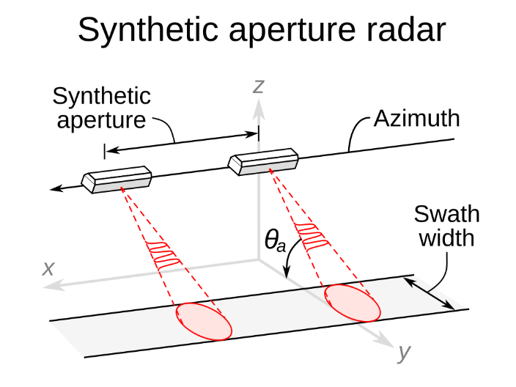

Fig 1. Geometry of observations used in synthetic aperture target

To give a brief about SAR imaging. SAR is an imaging radar which is mounted on a non-stationary platform. EM waves are transmitted in specific time intervals and the echoes are collected back and stored digitally. Since, transmission and receptions occur at two different intervals, they simultaneously map to two different positions too. The range direction is perpendicular to the flight track and perpendicular to the azimuth direction, as shown in Figure 1. The 3-D generation is done in 2 stages; firstly, 2D high resolution images are generated with the help of the azimuth and range direction, after which the phase differences are measured between the images. The height information, along with the azimuth-range coordinates provided by 2-D SAR focusing; gives the third dimension.

The SAR simulation method can be categorized into two: signal level and image level. The signal level simulation method focuses on the electromagnetic scattering process [4]. The common ground electromagnetic scattering model is related to the accuracy of the CAD model. With the high time and space complexity, it is not an economically viable method to establish an accurate computer-aided drafting model for each different target in the image. Respectively, the image level simulation method refers to the use of existing or hypothetical scattering coefficient maps to simulate SAR data. Though the electromagnetic scattering is not considered, this method is getting attention with the development of deep learning generation models.

Following the advent of deep learning in 2013, it has become a popular tool for many applications, such as image recognition, classification, semantic segmentation, target detection, etc. One of the very first milestones achieved is the introduction of VGG (Visual Geometry Group) Networks, a pre-trained neural network used for ImageNet in order to define the content and style (nature of) information of images, which provides a framework for image translation under the background of deep learning. Another milestone is the invention of Generative Adversarial Networks (GANs) that was made by Goodfellow et al. [5]. It

has been widely used in image processing fields, such as image super resolution, image restoration, and image style conversion. The high-resolution quality images produced by GAN are improving by each of its version, right now StyleGAN2 is the standard state-of-art method [6]. Since GAN as a concept is already in use in various fields like image restoration, image super resolution and image style conversion, so the thought emerged of why not apply it for a purpose which would reduce SAR generation costs and produce high quality SAR images. However, there are several hurdles which have to be repressed to get the appropriate results, some of which are immense amount of training (huge processing powers) and gradient disappearance of GANs.

This technical report goes through a series of increments in GANs. Following are the details: -

1. Understand the GAN structure and implement the most basic GAN model which is Deep Convolution Generative Adversarial Network (DCGAN) [7].
2. Implementation of latest GAN models which are the current state of art and bring about specific required changes to understand its architecture and imbibe the whole structure.
3. Implementation of a real-life problem solution especially for research institutes like DRDO (under whom this whole project is guided), which is synthesis of SAR images by StyleGAN2.
4. Other methodologies of imaging which help in various fields can also be generated using GAN, here Pix2Pix [15] with thermal image generation is depicted.
5. Further ahead, crude ship sketches are used to synthesize realistic images of the same using SketchyGAN.
6. **PROJECT DESCRIPTION AND GOALS**

2.1 Introduction to Generative Adversarial Networks (GANs)

Generative Adversarial Networks are developed using Deep learning architectures like convolution neural networks to generate various models. They are also called generative models because these GANs can produce new content, which can be text, images or music. Generative modelling is a type of unsupervised learning which learns from the various patterns and intricacies of the data in such a way that this very same model can be used to produce or generate similar examples as the input dataset.

A GAN in general consists of 2 neural networks trained together by a zero-sum game [8], which is nothing but a competition to outplay one another. The first block is a Generator which synthesizes fake data to mimic the real data and the second block is called a Discriminator whose job is to distinguish between real and fake data. We can compare this to a real-life situation wherein a generator acts like a counterfeiter and the discriminator is the cop who has to identify the fakes.

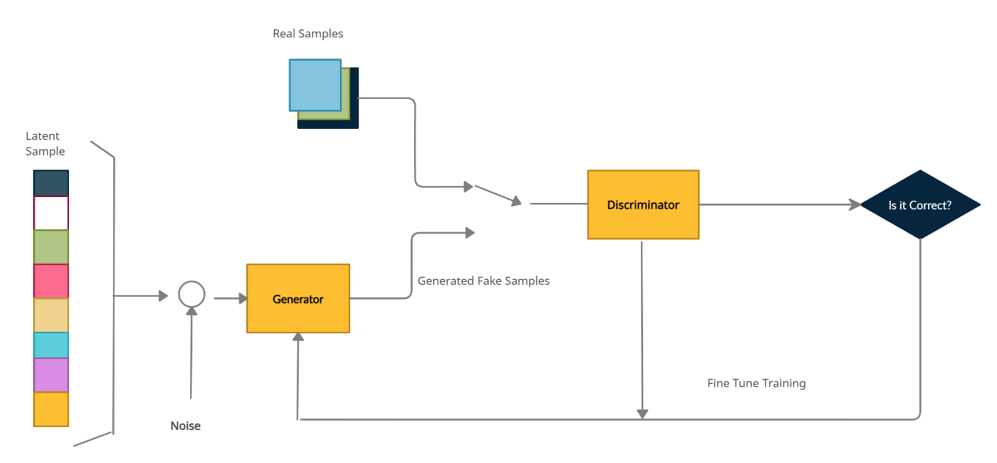

Fig 2. Generative Adversarial Network Flowchart

The whole process of understanding GAN can be categorized into 3 sections which follow: -

1. Process of generating Random variables (R.V’s) from a given distribution

Computers are fundamentally deterministic; thus, algorithms need to be defined specifically to generate sequence of numbers whose properties are very close to the theoretical random numbers. Therefore, uniform R.V’s can be pseudo-generated. (Uniform R.V’s generate a sequence of uniform random distribution between 0 and 1)

These R.V’s are expressed as a result of an operation or process. Different techniques are aimed at more complex R.V’s like Rejection Sampling and Inverse Transform Method.

* Rejection Sampling- R.V result from a well-known simple distribution is taken and then accepted/rejected by the sample depending on some specific pre-defined condition. [9] This whole process repeats until the sample value is accepted completely.
* Inverse Transform Method- The whole idea is to represent the complex R.V as a result of a function applied to a uniform R.V (which is already known).

Here a one-dimensional example is considered. Let X be a complex random variable we want to sample from and U be a uniform random variable over [0,1] we know how to sample from. We remind that a random variable is fully defined by its Cumulative Distribution Function (CDF). The CDF of a random variable is the probability that X will take a value less than or equal to X and defined, in one dimension, such that [8]



In the particular case of our uniform random variable U, we have



For simplicity, we will suppose here that the function CDF_X is invertible and its inverse is denoted

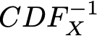

(the method can also be easily extended to the non-invertible case but since that is not the main focus here, I shall skip it). Then if we define

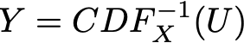

we have



As we can see, Y and X have the same CDF and then define the same random variable. So, by defining Y as above (as a function of a uniform random variable) we have managed to define a random variable with the targeted distribution.

To summarise ITM is a way to generate a random variable that follows a specific distribution when a uniform variable goes through a well-structured transform function. Conceptually, the purpose of the transform function is to reshape the initial probability distribution [Highest to the lowest is mapped].

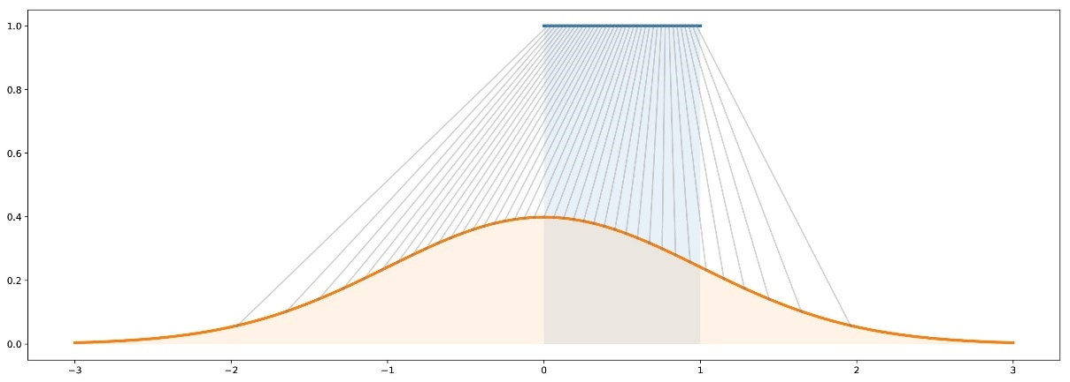

Fig 3. Mapping of CDF from Uniform to Gaussian

1. Generative Models: -

The generative models[12] can be explained with the help of an example here. Let’s take an image of a dog and suppose our target is to generate Black and White (B/W) square images of dogs (n x n) pixels.

We can reshape each data as N=(n^2 x1) dimensional vector (by stacking columns on top of one another) such that an image of a dog can be represented by a vector. However, it doesn’t mean that all the vectors represent a dog once shaped back to a square. [ Some points are very likely to represent dogs whereas it is highly unlikely for majority of others]

Thus, by the whole example we can deduce that the problem of generating a new image of a dog is equivalent to generating a new vector following “dog probability distribution” over the N dimensional vector space. Hence, two issues arise, one being that the dog probability distribution is a very complex distribution over a large space and the second being the explicit expression of this distribution. [19]

The first solution to this issue can be to use transform method with neural network as a function. Here, we will generate N uncorrelated uniform R.V by using the transform method. To do so, we need to express N dimensional R.V as a result of very complex function applied to a simple N dimensional R.V. We have to keep in mind that the transform cannot be explicitly expressed and thus, we have to learn it from the data. The main idea is here is to model the transform function by a neural network that takes as input a simple N dimensional uniform R.V and that returns as output another N dimensional R.V that should follow, after training, the right “probability distribution”.

1. Generative Matching Networks (GMN): -

We need to optimise(train) the network to express the right transform function, which can be done in two ways:

Direct one- comparing the true and generated probability distributions and backpropagating the difference (the error) through the network (GMN Matching).

Indirect one- involves no direct comparison. Here the generative network is trained by making the ‘true’ and ‘generated’ distributions go through a downstream task. The task is chosen in such a way that it enforces the generated distribution to be close to true distribution.

Since there are no explicit expressions available, so the only way to compare the probability distribution is based on the samples. Here, we have a sample of true data and we can, at each iteration of the training process, produce a sample of generated data. The method used for this training process is MMD (Maximum Mean Discrepancy) approach. It defines the distance between 2 probability distribution functions that can be computed based on samples of these distributions.

The idea of GMN is to optimise the network by repeating the following steps:

* Generate data with Uniform distribution.
* Make these inputs go through the network and collect the generated outputs.
* Compare the true “distribution function” and the generated one based on available samples.
* Use backpropagation to make one step of gradient descent to lower the distance between true and generated distributions.

Next, comes the Indirect Training Method which is nothing but the GANs.

As mentioned about the downstream task between true and generated samples is a discrimination task. In GANs, we have a discriminator, that takes samples of true and generated data and that try to classify them as well as possible. It trains the generator to match the target distribution. The discriminator is not known or perfect, in fact it is learned in this process.

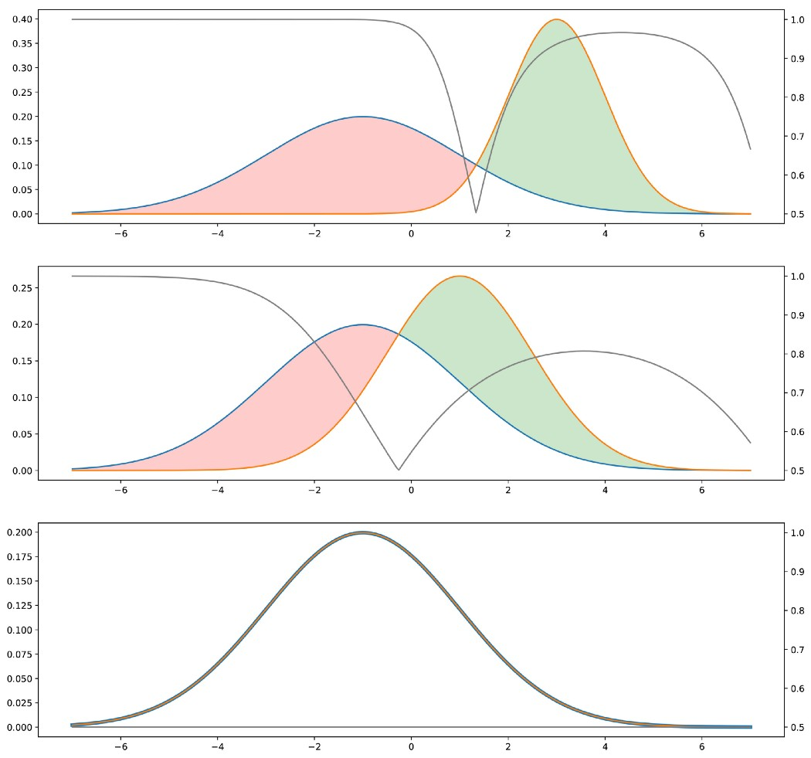

Fig 4. Generator and Discriminator depicted in graphical form

Intuition for the adversarial method. The pink distribution is the true one, the green is the generated one. In grey, with corresponding y-axis on the right, we displayed the probability to be true for the discriminator if it chooses the class with the higher density in each point (assuming “true” and “generated” data are in equal proportions). The closer the two distributions are, the more often the discriminator is wrong. When training, the goal is to “move the green area” (generated distribution is too high) towards the red area (generated distribution is too low).

The approximation- Adversarial Neural Networks:

Generator is a neural network that models a transform function.[16] It takes input sample RV and once trained; it outputs the RV that follows targeted distribution. As there are too many unknowns, a decision is made to model the discriminator with another neural network. It takes as input a point and returns as output the probability of this point to be a “true” one.

Once defined, the two networks can be trained jointly (with opposite goals): -

The goal of the generator is to fool the discriminator, so generative NN is trained to maximum final classification error. On the other hand, the goal of the discriminator is to detect the fake generated data. So, the discriminator NN is trained to minimise the final classification error.

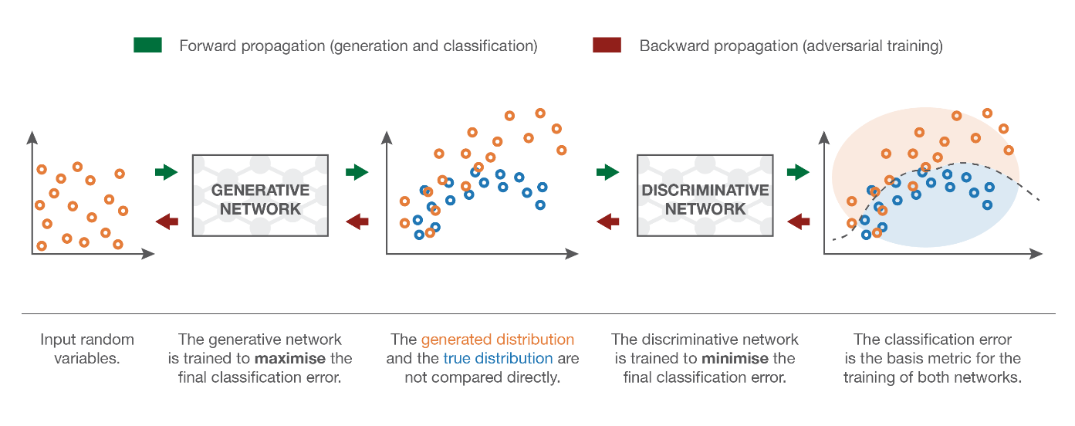

Fig 5. Flow of events of GMN and Discriminative Networks

Courtesy: https://towardsdatascience.com/understanding-generative-adversarial-networks-gans-cd6e4651a29

2.2 FURTHER EXTENSION OF GAN- STYLEGAN

2.2.1 Feature Space Normalization and Style Transfer

StyleGAN is an extension of Progressive GAN (ProGAN) wherein the image pixel is down sampled and then the necessary changes are done on it and then further it is up sampled to a high-quality image. Since the human system depends on image statistics, the channel wise mean and variance encode the style segments of an image. On the other hand, the spatially varying features encode a specific instance.

Batch Normalization: is required to understand and implement how to control style (which is the features) of the image in StyleGAN.

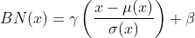

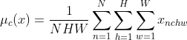

In the above equations, **N**is the number of image batch ***H*** the height and ***W*** the width. The “mu” (**μ)** refers to the mean and the “sigma” (**σ)** refers to the standard deviation. To be specific **γ, β** are vectors with the channel dimensionality. The batch features are **x** with a shape of [N, C, H, W], where the index **c**denotes the per-channel mean. Here, the batch image and the spatial dimensions are both averaged. In this manner, all the features are in a compact space which is highly beneficial.

**The γ, β** share the same learned characteristics. On the whole, *BN* (Batch Normalization) can be understood as normalizing a batch of images to be centered around a style. But still the neural network learns various styles which are non-existent or very minute, thus every single sample will have different styles. This is desirable in some real life scenarios and undesirable in other.

2.2.2 Instance Normalization

Unlike BN, Instance Normalization (IN) is calculated across the spatial dimensions independently for each sample. It is experimentally validated that the affine parameters in IN can totally change the output image. As opposed to BN, **IN can normalize the style of each individual sample to a target style** (modeled by γ and β). Thus, training a model to transfer to a pre-defined style is easier. For one to design a plethora of finite styles, all one has to do is introduce multiple γ, which is the case of conditional instance normalization.

2.2.3 Adaptive Instance Normalization (AdaIN)

In this method, γ and β are taken from another image and we can model any arbitrary style by just inputting the mean as **β and variance as γ. AdaIn takes in the content (x) and a style input (y) and matches the channel wise mean and variance to y.** To summarize, AdaIN performs style transfer (in the feature space) by aligning the first-order statistics (μ and σ), at no additional cost in terms of complexity.

2.3 STYLE BASED GENERATOR

As explained in Section 2.1, in a common GAN generator, the sampled input latent space vector z is projected and reshaped, so it will be further processed by [transpose convolutional](http://d2l.ai/chapter_computer-vision/transposed-conv.html). Here, the latent vector is transformed by a series of fully connected layers, the so-called **mapping network *f*.** This results in another learned vector *W*, called intermediate latent space *W*.

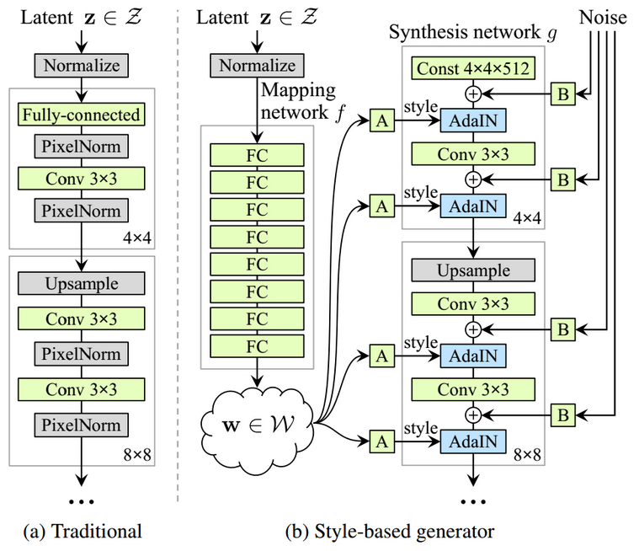

Fig 6. Flow Chart of StyleGAN2

2.3.1 Understanding the StyleGAN2 Flowchart

One of the major reasons of choosing the Mapping network *f* is because of the intermediate latent vector *W* which does not support sampling according to any fixed distribution. With continuous mapping, its sampling density is induced. This mapping *f* “unwraps” the space of *W*, so it implicitly enforces a sort of **disentangled representation**. This means that the factors of variation become more linear. Furthermore, the authors of [9] provide **Generator** with explicit noise inputs, as a direct method to model stochastic details. **B** blocks are single-channel images consisting of uncorrelated Gaussian noise. They are fed as an additive noise image to each layer of the synthesis network. The single noise image is broadcasted to all feature maps.

Except for the initial block, each layer starts with an up-sampling layer to double spatial resolution. Then, a convolution block is added. After each convolution, a 2-Dimensional per-pixel noise is added to model stochasticity. Finally, the learned intermediate latent space that corresponds to style is injected.

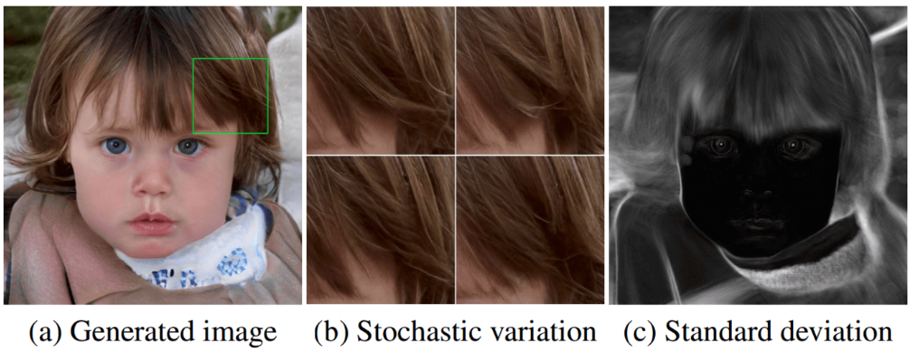Fig 7. StyleGAN2 results from the original paper [21] showing slight variations in style

Image source: https://arxiv.org/abs/1812.04948

The reason for this localization, starting from style. AdaIN operation first normalizes each channel to zero mean and unit variance. Then, it **applies the style-based scales and biases**. In this way, the feature statistics for the subsequent convolution operation are changed. Less literally, **previous statistics/styles are discarded** in the next AdaIN layer. Thus, each style controls only one convolution before being overridden by the next AdaIN operation.

In a conventional generator, the latent vector *z* is fed in the input of the network. This is considered sub-optimal as it consumes the generator’s learning capacity. This is justified as the need of the network to invent a way to generate spatially-varying numbers from earlier activations.

2.4 LAYOUT OF THE PROJECT

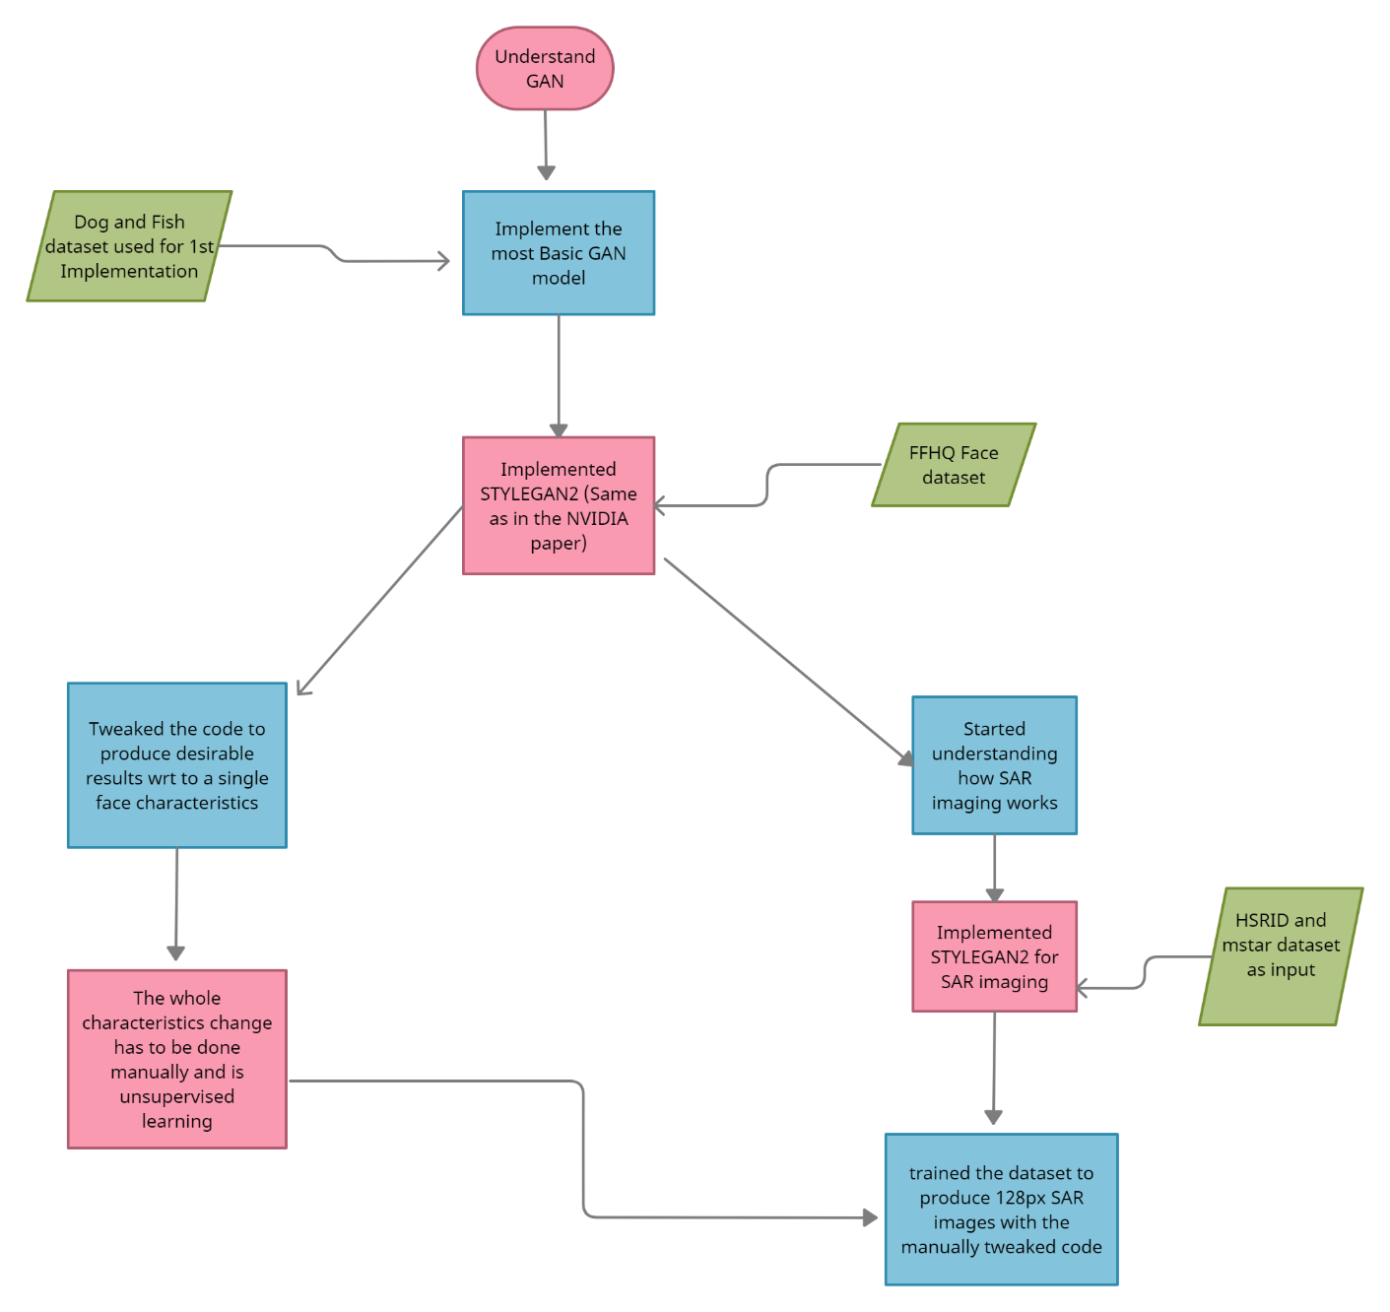

Fig 8. Flow of Events of the whole Project

1. **TECHNICAL SPECIFICATIONS**

The whole project was developed and implemented on google colab on a Laptop. Following are the specifications of the laptops: -

RAM- 12GB

Processor- Intel i5- 10th Gen

Graphics Card- NVIDIA M400- 2GB

256GB SSD

Here are the details about google colab: -

Google collaborator is a free cloud service based on Jupyter Notebooks that supports free GPU. It allows absolutely anyone to develop deep learning applications using popular libraries such as **PyTorch, TensorFlow, Keras,**and**OpenCV.** It supports **Python 2.7** and**3.6**, but not **R** or **Scala** yet. There are of course many training time limits but we shall talk about it in trade-offs and limitations due to the pandemic.

We can create notebooks in Colab, upload notebooks, store notebooks, share notebooks, mount it onto the Google Drive and use whatever that is stored in it, Jupyter Notebooks, upload notebooks directly from GitHub, upload Kaggle files, download notebooks, and many other entities.

There are a few steps which have to be followed in order to make the google colab environment more enticing: -

* Setting up the drive🡪 Go to google drive🡪 Click New🡪 Create a New Folder OR
* Click New🡪 More🡪 Colaboratory
* Set up the GPU🡪 Go to runtime🡪 select change runtime type-🡪 select GPU or TPU
* One most important step is to mount the google drive by using:

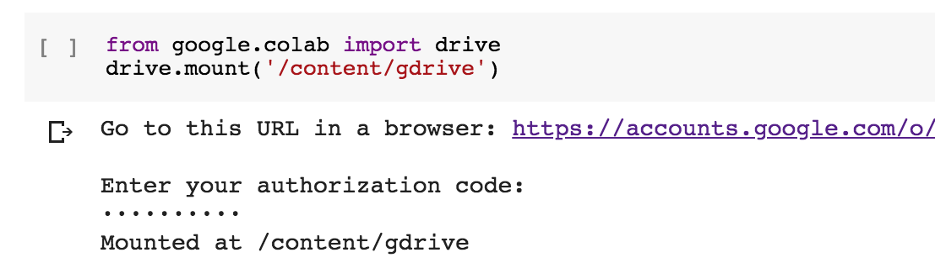

Fig 8. Colab setup with Google Drive

After setting up the colab environment, we have to upload the dataset which can be done either through google drive or directly from the local disk space. Hence forth, the dataset will have to be mounted every time the session goes inactive which is one of the main issues with Goggle colab. Adding to this google doesn’t encourage large training times from a single account since, they have developed google collaborator for the purpose of knowledge and not for the purpose of running personal projects by using free GPU’s. Also, Google colab Pro is available for the same reason which is running/ training for long period of times but the bad news is that it is currently only available in US and Canada. Thus, the only resort we have is to use the free version and accept defeat from google whenever we are red flagged as defaulter.

1. **DESIGN APPROACH AND DETAILS**

4.1 INTRODUCTION TO THE FLOW OF EVENTS

Since directly implementing the state-of-art GAN is very difficult and to understand it simultaneously makes the task all the more tough. So, I split the whole project into 2 alternatives:

1. Implement the Basic GAN models like DCGAN, ProGAN and then StyleGAN2. Then, implement my own ideas into the code script for facial changes as and when required. Finally, implement SAR dataset.
2. If the whole idea of SAR[17] images doesn’t pan out, use pix2pix to work with thermal and google map images generations using GAN applications.

4.1.1 IMPLEMENTATION OF BASIC GAN MODELS

Since the whole model of GAN has already been introduced in Section 2, I will go ahead with the main algorithm, its supporting pre requisites and the various datasets used.

Algorithm:

* Sample a noise set and a real data set, each of the same size m
* Train the discriminator
* Sample a different noise subset of size m
* Train the generator on this dataset
* Repeat from the first step.

Here are the detailed explanations with mini code snippets:

1. Mount the google drive. This is for two things

Saving results and checkpoints for later reuse and loading our own custom datasets.

1. Extract the custom data and either store it directly in the drive or unzip the zipped file.

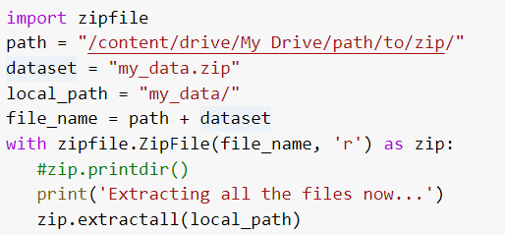

1. We need to pull out the latest version of stylegan2-ada from github repository and even use the right version of Tensorflow which is any version of Tensorflow 1.

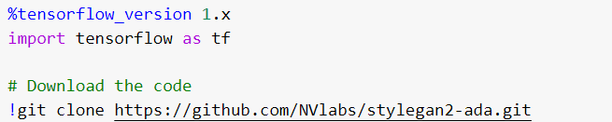

1. Download weights for transfer learning if we don’t already have .pkl file existing already or are starting the training from the scratch.
2. Further, we need to tweak the code according to our need which is usually adjusting the pixel size i.e resizing the image and all. This process is sometimes called surgery.



1. Then, the weights are coped onto the empty network and the data is prepared.

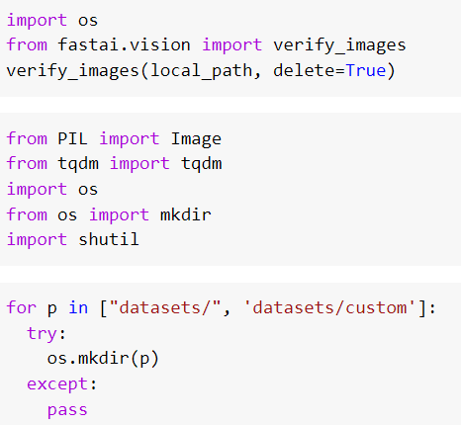

1. Further ahead, the training of the network is started with the dataset and the main code.

key things to look at:

* Resume – this has to be changed if we want to carry on training a model after a timeout, or use a pre trained model to transfer learn. By default its set to the original FFHQ1024x1024 from the Stylegan2 paper.

If we want to use the surgery weights, we created earlier replace the value with our surgery weights. For example:

[/content/surgery_output.pkl](https://colab.research.google.com/github/Hephyrius/Stylegan2-Ada-Google-Colab-Starter-Notebook/blob/main/Stylegan2_Ada_Colab_Starter.ipynb)

* Outdir – used if we want to save grids and weights to a different folder on our google drive.
* Cfg – used when we want some specific changes in the image configurations like mirroring left to right or top to bottom etc.

1. Post training, a few images can be displayed for the sake of it and we can clearly see that each image produced is unique and computer generated. This was the whole aim of unsupervised deep learning of GAN.

**4.2 WOKING OF DISCRIMINATOR**

The very first step is to make all the images of the same dimensions/configurations. (3x3 Kernel size).

128px height x 128px width x 3(RGB)

An API sequential model, it’s a keras inclusive linear stack of layers, this helps us create and define how and which layers are connected. As mentioned, 1 input layer and 4 hidden layers are defined. This 1 input layer consists of 64 filters, each of kernel size 3x3; all the padding is set to same, so that input and output dimensions come out to be same.

The ReLu (Leaky ReLu) activation function is used which is defined as: -

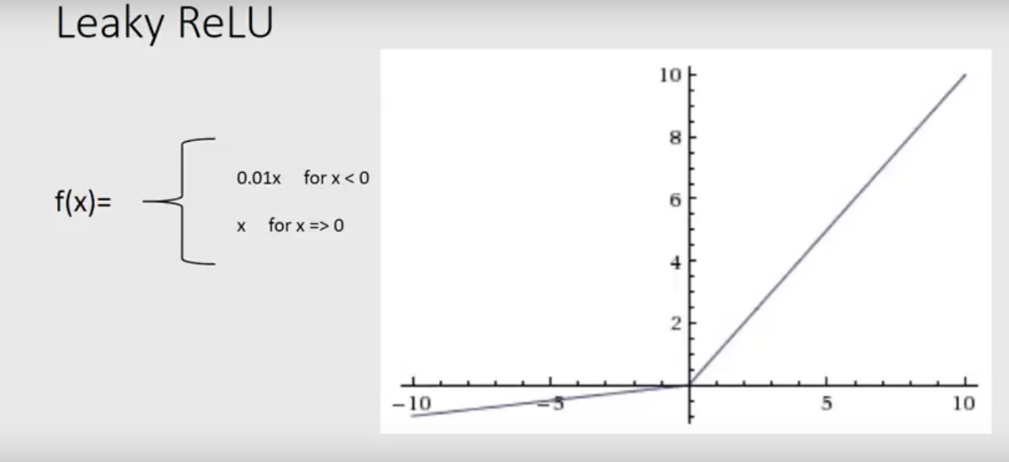

Fig9. Leaky ReLu activation function

The slope of the activation function is set to 0.2 as given in the NVIDIA journal. Next comes pooling; pooling is either done to down sample or up sample the feature map using strides to define the pixel length and width needed to be taken in.

Furthermore, ‘Flatten’ function is used to convert the data into 1-Dimensional array for inputting it into the next layer. This is done to create output of convolution layer of a single long 1-D vector. Dense layer is nothing but a fully connected layer i.e neurons in one layer are connected to those in the next layer.

Loss function used is Binary-cross entropy wherein the threshold set is: -

Fake images=0

Real images=1

Binary classification is done.

**4.3 DEFINING GENERATOR MODEL**

The latent vector is the key here. A latent vector is a Gaussian distribution value from this space randomly mapped to points which the generator will assign some meaning to the values and then convert it into images. (In short mean=0 and S.D=0)

Feature map consists of n nodes =256*8*8 (Here 256 is the latent points which will be parallelly processed). Input layer is a dense layer i.e input dimension = latent dimension.

Post reshaping them, up sampling or deconvolution is performed on the latent vector. Here, 128 filters; 2x2 strides is used which doubles the size of the images. Therefore, the generator is indirectly trained by the discriminator. No optimiser is used in the end of the generator code as it is not a standalone model rather both discriminator and generator have to work together to learn.

**4.4 OTHER PROCESSES EXPLAINED**

4.4.1 Combining both the models

Both the models are combined and the trainable parameter is set to FALSE because weights should not be updated within the combined model.

4.4.2 Load Real Images

Image data Generator from Keras is used. The target size is set for uniformity. Then, the images are converted into nparray and returned.

4.4.3 Generate Real Images

An image is picked from the real_images np array and random function is used to pick up and mix up and give us an image. The generate latent points function is used as a parameter to generate fake images and model.predict() is used to perform the above function.

4.4.4 Evaluation of GAN performance

Firstly, we have to go by the quality of the images by naked eye as our first line of performance analysis and only later when images become indistinguishable to naked eye, we have to use other parameters like FID (Fréchet Inception Distance score) and IS (Inception Score).

FID is a metric that calculates the distance between feature vectors calculated for real and generated images. [Lower the FID score, better the model]

Inception Score or IS for short, is an objective metric for evaluating the quality of generated images, specifically synthetic images output by generative adversarial network models. [Higher the score, better the image quality]

**Moving ahead to the parallel project of RGB to Thermal image generation.**

**4.5 THERMAL IMAGE GENERATION**

Thermal images have useful discriminative properties. Concretely, warm bodies (i.e. humans, animals, hot vehicles, etc.) tend to be objects of interest.

Unfortunately, thermal cameras:

* Are **expensive**
* Have a **narrow field of view**
* Are **not sufficient for** all the tasks of **perception** (e.g. cannot read traffic lights)

For these reasons, one method proposed in recent times is the use of RGB cameras for perception tasks such as semantic segmentation.

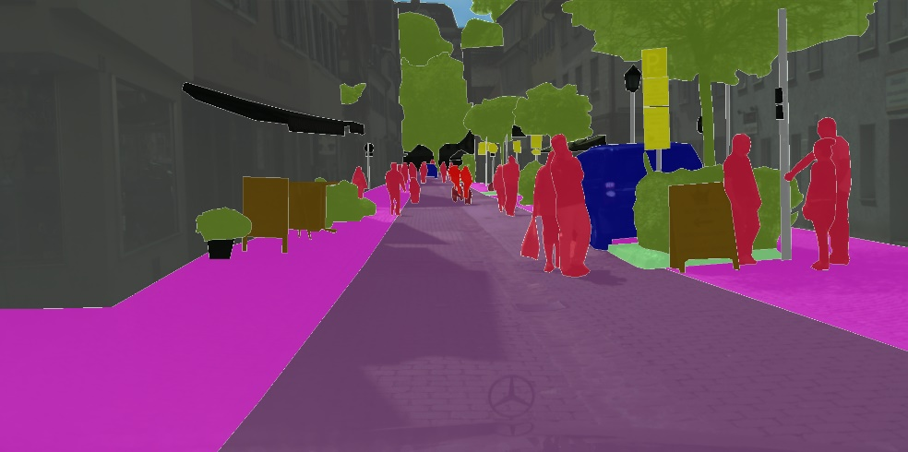

Fig 10 . RGB Cityscape view

So, the main aim of this sub section is to convert RGB images into thermal images so that cost cutting can be achieved at the same time the quality is not compromised with.

For my experiments I used the FLIR thermal dataset, which has 14k paired RGB and thermal images (split into train and validation sets). The dataset also has bounding box labels for some objects. CycleGAN [11]was used in this part of the project.

CycleGAN is perhaps one of the most elegant methods in deep learning. It works roughly as follows:

1. A Convolutional Neural Network (CNN) takes an image from domain A and generates an image in domain B. A -> B’.  
   A discriminator will force the generated image to look like it is from the target domain (thermal images).
2. A CNN in the opposite direction will generate a reconstruction B’->A’.  
   A simple L1 loss between the original image and the reconstruction will force the intermediary fake image B’ to contain all the necessary for the reconstruction. It is for this reason the generated images look like the inputs, but in the target domain, and not some random images from the target domain.

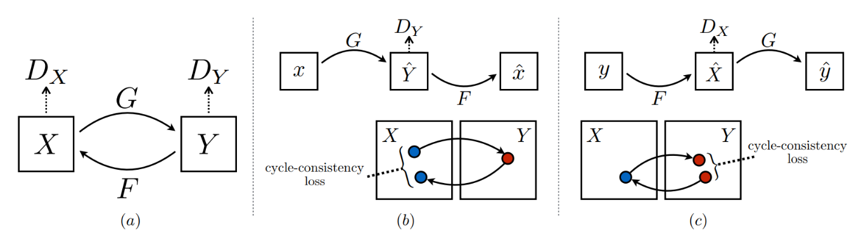

Fig 11. CycleGAN losses. (a) — discriminator losses, (b), (c) reconstruction (cycle-consistency) losses.

To be the algorithm in simple steps: -

1. Take the 2 images x and y (1 from Domain X and 1 from Domain Y )
2. Run the two generators (x2y and y2x) → generate 2 fake images(y’,x’)
3. Run the two discriminators (DX and DY ) DX takes x and x’ , DY takes y and y’
4. Calculate the discriminators losses from above equations
5. Run again the two generators, x2y (x’ as the input) and y2x (y’ is the input) generates two cycle images (y_cycle, and x_cycle)
6. Calculate the cycle l1 loss from (x,x_cycle and y,y_cycle)
7. Finally calculate the generator loss.

4.5.1 Pix2Pix for Thermal Image generation

The name itself says “Pixel to Pixel” which means, in an image it takes a pixel, then converts that into another pixel.[22] The goal of this model is to convert from one image to another image, in other words the goal is to learn the mapping from an input image to an output image. There are tonnes of applications for this which is depicted in the image below:

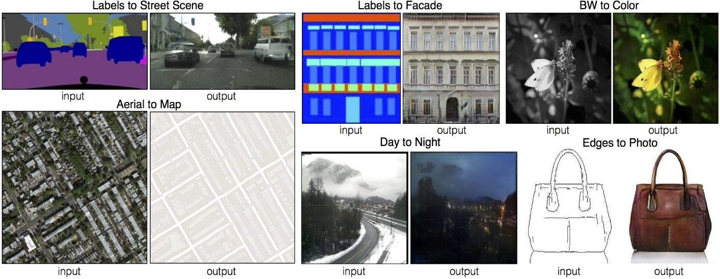

Fig 12 . Various applications of Pix2Pix

**Algorithm**

* Training data pairs ( **x** and **y** where **x** is the input image and **y** is the output image)
* Pix2Pix uses the **conditional GAN (CGAN) →**G : {x, z} → y. (z → noise vector, x → input image, y → output image)
* Generator Network ( Encode- decode architecture) as an image is the input , we want to learn the deep representation and decode it.
* CGAN loss function and L1 or L2 distance.

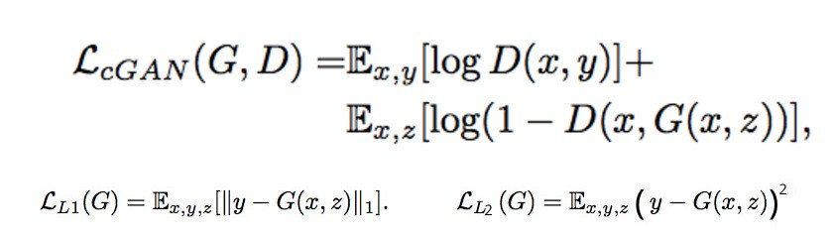

Fig 13 . Conditional GAN Equations

Training Process:

→ The Generator G takes x and z which then produces y, the goal of the G is to produce output images that cannot be distinguished from “real” images by the discriminator.

→ The discriminator D takes the pair (x and y) from both real images and fake images. The goal of the D is to distinguish between fake and real inputs.

Training a Pix2Pix GAN is same as training any normal GAN except a little modification has to be done at the generator’s loss function. The generator G is not only trying to reduce the loss from discriminator but also trying to move the fake distribution close to real distribution by using L1 or L2 loss.

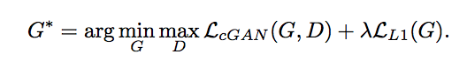

Fig 14. Loss Function of Generator Network

The network architecture used here is U-Net with skip connections. The whole idea in this architecture is that the images are down sampled first, then the necessary action is performed and finally images are up sampled. That’s how the U shape comes into existence and so is the name. [21]

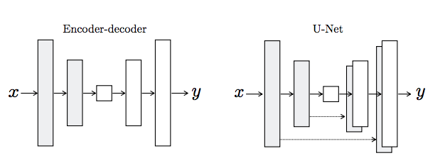

Fig 15. U-Net Architecture

Here are the main code snippets:

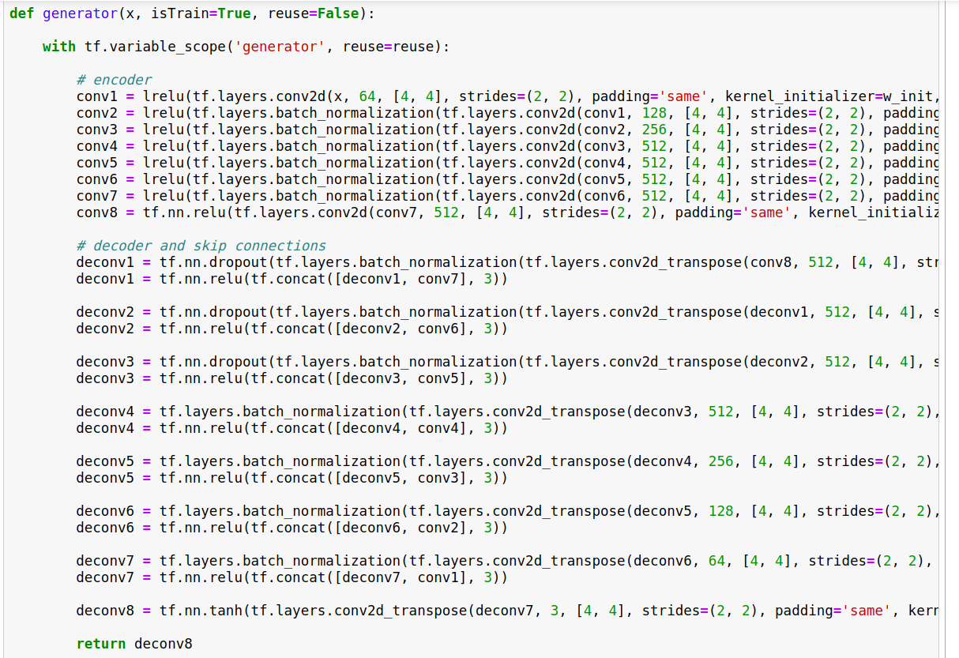

Fig 16. Generator Model

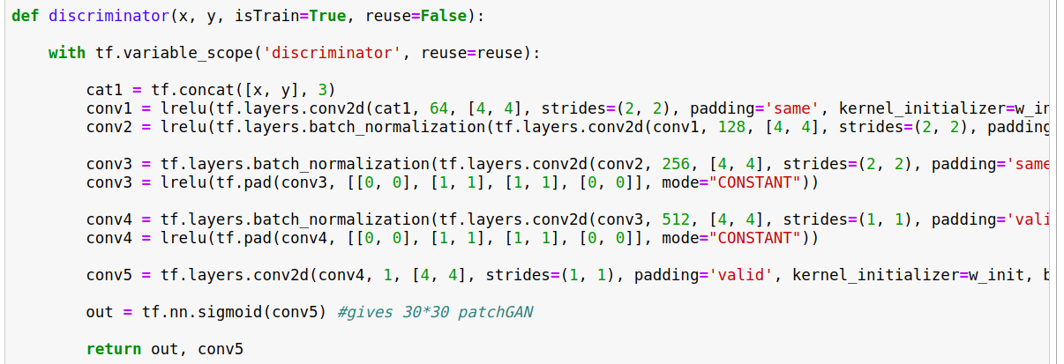

Fig 17 . Discriminator Model

The discriminator is a simple network (a bunch of down sampling layers and at the end we get the patch GAN, a grid of 30*30 values or pixels where each pixel is classified how much fake or real (between 0 and 1).

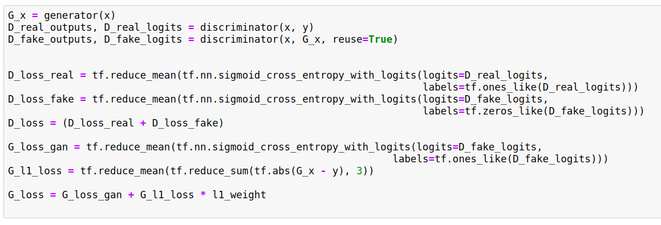

Fig 18 . Down sampling in discriminator

The G loss has now 2 components, one is the normal generator loss and another one is the weighted L1 loss between generated x (fake image) and real y. Below is the Training Snippet.

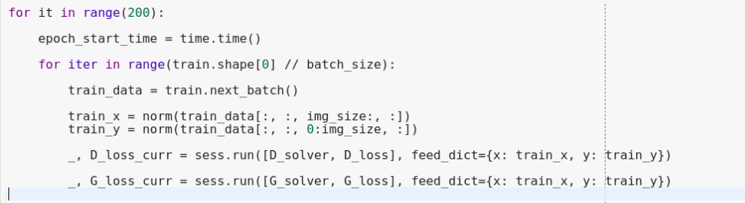

Fig 19. Training snippet

**4.6 ALTERNATIVES, TRADEOFFS AND CONSTRAINTS**

Constraints

One of the main aspects which had to be compromised with was technical limitations. Since, the whole project was implemented from a WFH situation wherein the only access and usage point is my Laptop which has limited resources. Adding to this, google colab has its training limits too, any long training time by users is detected by google and the user is red flagged. The same has happened to me on various occasions causing my gmail account altogether getting suspended for weeks.

Alternatives

A very viable, but not so feasible alternative to this computational and processor power limitation can be the use of external processors like Jetson nano. But, at the same time, a whole new domain of embedded systems comes into play and need to convert the code to C# or any other language that is accepted by these devices. Therefore, buying an external processor is an option of last resort.

1. **SCHEDULE, TASKS AND MILESTONES**

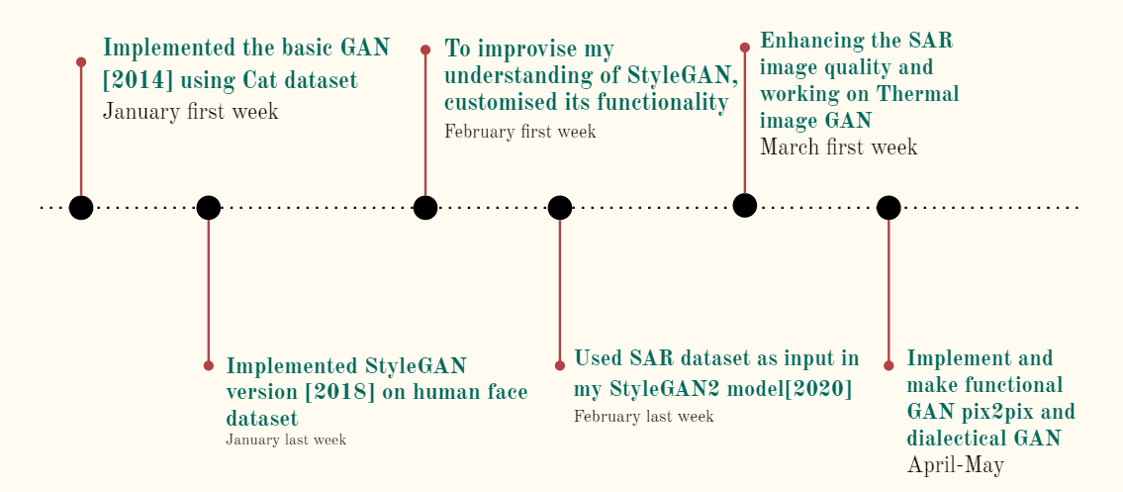

Fig 20. Overview of Project Timeline

1. **DATASETS USED**

6.1 FFHQ Dataset

The dataset consists of **70k+ HD (high quality)** PNG images at **512×512** and even 1028x1028 resolution. This required resolution can be chosen as and when required by just exporting it by the original NVIDIA GitHub repository. The dataset is a combination of various ethnic groups, age and background of peoples’ face images. It also has good coverage of accessories such as sunglasses, hats, eyeglasses etc. The images were mostly picked up from from Flickr, thus automatically inheriting all the biases from the websites too. Few sample images are shown below: -

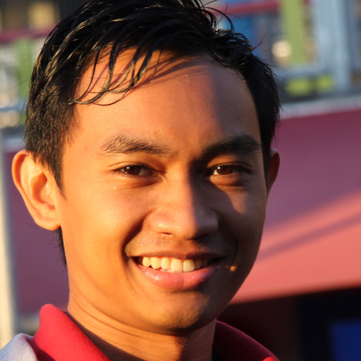 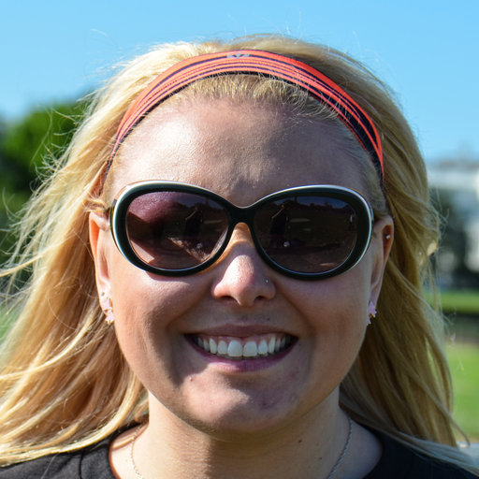

Fig 21. Sample FFHQ face dataset

6.2 HSRID dataset

HSRID stands for High resolution SAR images dataset. It is a data set for ship detection, semantic segmentation, and instance segmentation tasks in high-resolution SAR images. This dataset contains a total of 5604 high-resolution SAR images and 16951 ship instances. HRSID dataset has high quality 1-ship, 2-ships, multiple ships and even landscape SAR images which are 800x800 pixels in dimension. It has far better outreach than MSTAR dataset. Thus, it helped in faster learning for the DL model. This dataset is a benchmark for researchers to evaluate their approaches.

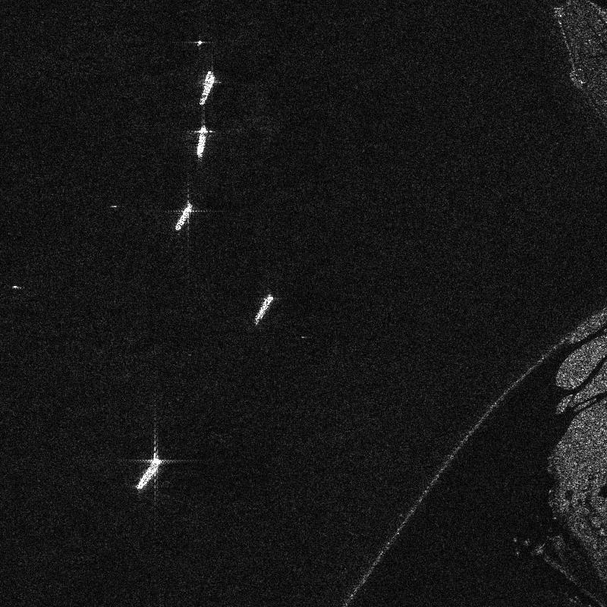 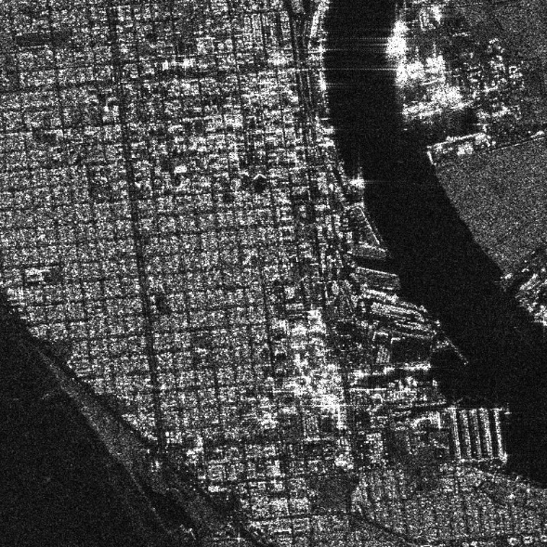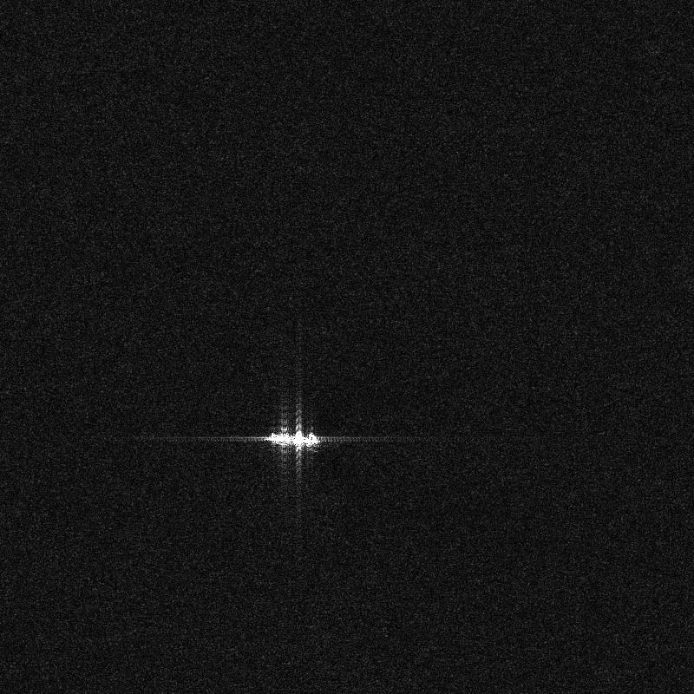 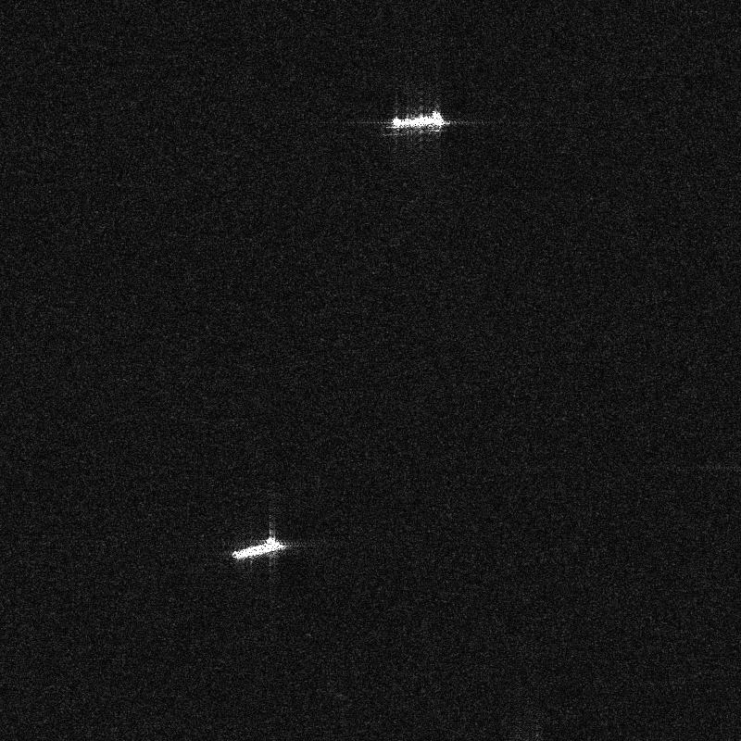

Fig 22. Sample image HSRID dataset of all 4 varieties

6.3 FLIR dataset

FLIR dataset is a thermal dataset of images and videos which are usually used in automotive industries for driverless driving learning. It has Synced annotated thermal imagery and non-annotated RGB imagery for reference, with over 14k images and 10k short videos of people, dogs, cars and bicycles. Mostly the images are even labeled to show the same classifications as mentioned which helps individuals in training their CNN. But, in this project FLIR dataset was solely used without the labels for image to image conversion. Here are a few sample images: -

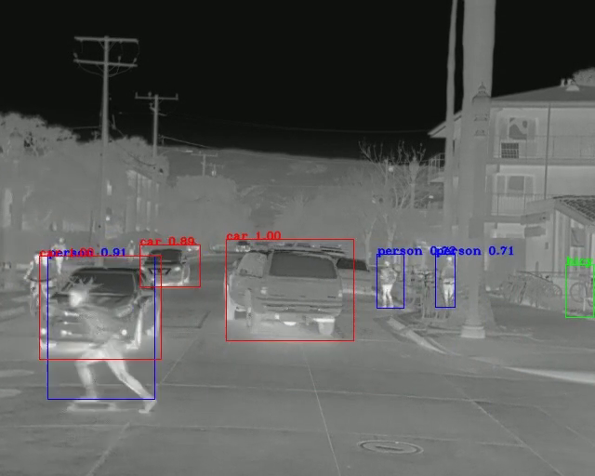 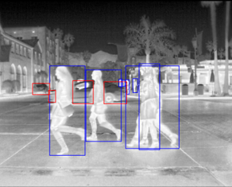

Fig 23. Sample FLIR dataset images

6.4 Marvel Ship sketch images dataset

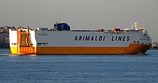 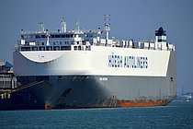

Fig 24.Original Ship dataset from Marvel dataset

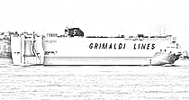 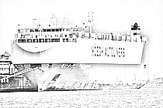

Fig 25. Representation of sketch equivalent of the original ship images

1. **PROJECT DEMONSTRATION**

This whole section only consists of the main code snippets from all the varieties of steps of my project.

**7.1 DCGAN on Cat dataset**

Below is the code for DCGAN used for producing cats: -

First let’s look at sample cat dataset images

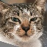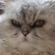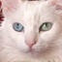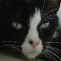

Fig 26. Sample cat dataset images

The main code snippets are as follows [10]: -

# discriminator model

def define_D(in_shape=(128,128,3)):

    model = Sequential()

    model.add(Conv2D(64, (3,3), padding='same', input_shape=in_shape))

    model.add(LeakyReLU(alpha=0.2))

    model.add(Conv2D(64, (3,3), strides=(2, 2), padding='same'))

    model.add(LeakyReLU(alpha=0.2))

    model.add(Conv2D(64, (3,3), strides=(2, 2), padding='same'))

    model.add(LeakyReLU(alpha=0.2))

    model.add(Conv2D(64, (3,3), strides=(2, 2), padding='same'))

    model.add(LeakyReLU(alpha=0.2))

    model.add(Flatten())

    model.add(Dropout(0.4))

    model.add(Dense(1, activation='sigmoid'))

    opt = Adam(lr=0.0002, beta_1=0.5)

    model.compile(loss='binary_crossentropy', optimizer=opt, metrics=['accuracy'])

    return model

Model: "sequential"

_________________________________________________________________

Layer (type) Output Shape Param #

=================================================================

conv2d (Conv2D) (None, 128, 128, 64) 1792

_________________________________________________________________

leaky_re_lu (LeakyReLU) (None, 128, 128, 64) 0

_________________________________________________________________

conv2d_1 (Conv2D) (None, 64, 64, 64) 36928

_________________________________________________________________

leaky_re_lu_1 (LeakyReLU) (None, 64, 64, 64) 0

_________________________________________________________________

conv2d_2 (Conv2D) (None, 32, 32, 64) 36928

_________________________________________________________________

leaky_re_lu_2 (LeakyReLU) (None, 32, 32, 64) 0

_________________________________________________________________

conv2d_3 (Conv2D) (None, 16, 16, 64) 36928

_________________________________________________________________

leaky_re_lu_3 (LeakyReLU) (None, 16, 16, 64) 0

_________________________________________________________________

flatten (Flatten) (None, 16384) 0

_________________________________________________________________

dropout (Dropout) (None, 16384) 0

_________________________________________________________________

dense (Dense) (None, 1) 16385

=================================================================

Total params: 128,961

Trainable params: 128,961

Non-trainable params: 0

# generator model

def define_G(latent_dim):

    model = Sequential()

    # foundation for 16x16 image

    n_nodes = 256 * 16 * 16

    model.add(Dense(n_nodes, input_dim=latent_dim))

    model.add(LeakyReLU(alpha=0.2))

    model.add(Reshape((16, 16, 256)))

    # upsample to 32x32

    model.add(Conv2DTranspose(128, (4,4), strides=(2,2), padding='same'))

    model.add(LeakyReLU(alpha=0.2))

    # upsample to 64x64

    model.add(Conv2DTranspose(128, (4,4), strides=(2,2), padding='same'))

    model.add(LeakyReLU(alpha=0.2))

    # upsample to 128x128

    model.add(Conv2DTranspose(128, (4,4), strides=(2,2), padding='same'))

    model.add(LeakyReLU(alpha=0.2))

    model.add(Conv2D(3, (7,7), activation='tanh', padding='same'))

    return model

Model: "sequential_1"

_________________________________________________________________

Layer (type) Output Shape Param #

=================================================================

dense_1 (Dense) (None, 65536) 6619136

_________________________________________________________________

leaky_re_lu_4 (LeakyReLU) (None, 65536) 0

_________________________________________________________________

reshape (Reshape) (None, 16, 16, 256) 0

_________________________________________________________________

conv2d_transpose (Conv2DTran (None, 32, 32, 128) 524416

_________________________________________________________________

leaky_re_lu_5 (LeakyReLU) (None, 32, 32, 128) 0

_________________________________________________________________

conv2d_transpose_1 (Conv2DTr (None, 64, 64, 128) 262272

_________________________________________________________________

leaky_re_lu_6 (LeakyReLU) (None, 64, 64, 128) 0

_________________________________________________________________

conv2d_transpose_2 (Conv2DTr (None, 128, 128, 128) 262272

_________________________________________________________________

leaky_re_lu_7 (LeakyReLU) (None, 128, 128, 128) 0

_________________________________________________________________

conv2d_4 (Conv2D) (None, 128, 128, 3) 18819

=================================================================

Total params: 7,686,915

Trainable params: 7,686,915

Non-trainable params: 0

_________________________________________________________________

**7.2 StyleGAN2 on FFHQ dataset (Human faces)**

Sample dataset images followed by the main code snippets [12]: -

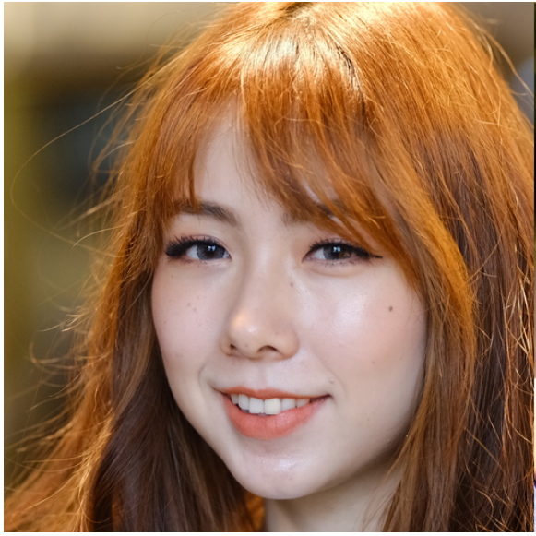 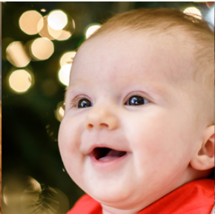

Fig 27. Sample FFHQ 1024px dataset images of human faces

def seed2vec(Gs, seed):

  rnd = np.random.RandomState(seed)

  return rnd.randn(1, *Gs.input_shape[1:])

def init_random_state(Gs, seed):

  rnd = np.random.RandomState(seed)

  noise_vars = [var for name, var in Gs.components.synthesis.vars.items() if name.startswith('noise')]

  tflib.set_vars({var: rnd.randn(*var.shape.as_list()) for var in noise_vars}) # [height, width]

def display_image(image):

  plt.axis('off')

  plt.imshow(image)

  plt.show()

def generate_image(Gs, z, truncation_psi):

    # Render images for dlatents initialized from random seeds.

    Gs_kwargs = {

        'output_transform': dict(func=tflib.convert_images_to_uint8, nchw_to_nhwc=True),

        'randomize_noise': False

    }

    if truncation_psi is not None:

        Gs_kwargs['truncation_psi'] = truncation_psi

    label = np.zeros([1] + Gs.input_shapes[1][1:])

    images = Gs.run(z, label, **Gs_kwargs) # [minibatch, height, width, channel]

    return images[0]

**7.3 StyleGAN2 on SAR images dataset**

Here are few sample SAR images first: [18] [20]

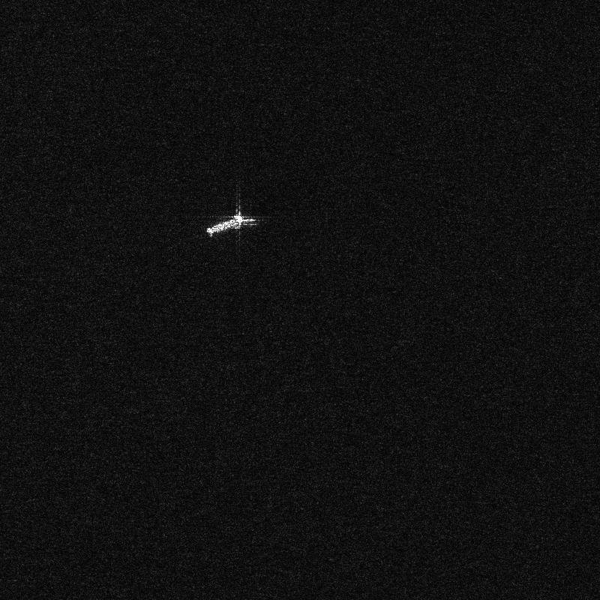 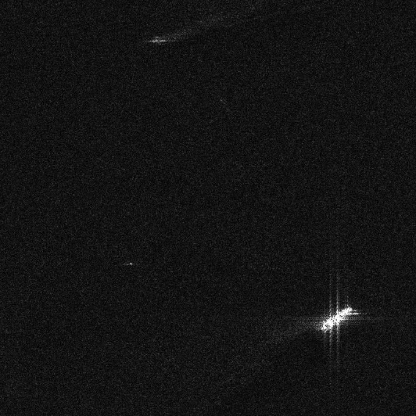

Fig 28. Sample 1 ship SAR images

# resize all the images to same size

import os

from tqdm import tqdm

import cv2

from PIL import Image

#from resizeimage import resizeimage

path = '/content/drive/My Drive/ships2/'

for filename in tqdm(os.listdir(path),desc ='reading images ...'):

  image = Image.open(path+filename)

  image = image.resize((512,512))

  image.save(path+filename, image.format)

dataset_name = "sartf"

#how often should the model generate samples and a .pkl file

snapshot_count = 6

#should the images be mirrored left to right?

mirrored = True

#should the images be mirrored top to bottom?

mirroredY = False

#metrics?

metric_list = None

#augments

augs = "bg"

resume_from = "/content/drive/MyDrive/colab-sg2-ada/stylegan2-ada/results/0015-sartf-mirror-mirrory-11gb-gpu-bg-resumecustom/network-snapshot-000016.pkl"

!python train.py --outdir ./results --snap={snapshot_count} --cfg=11gb-gpu --data=./datasets/{dataset_name} --augpipe={augs} --mirror={mirrored} --mirrory={mirroredY} --metrics={metric_list} --resume={resume_from} --augpipe="bg"

**7.4 Pix2Pix Code demonstration**

        # Define all convolutional layers

  # Should accept an RGB image as input and output a single value

        # 1st Conv layer has no batch_norm. dim = [64, 64, 64]

        self.conv1 = conv(3, conv_dim, 4, batch_norm=False)

        # 2nd Conv layer. dim = [32, 32, 128]

        self.conv2 = conv(conv_dim, conv_dim*2, 4)

        # 3rd Conv layer. dim = [16, 16, 256]

        self.conv3 = conv(conv_dim*2, conv_dim*4, 4)

        # 4th Conv layer. dim = [8, 8, 512]

        self.conv4 = conv(conv_dim*4, conv_dim*8, 4)

        # 5th Last Conv layer, Classification Layer has no batch_norm and stride is 1. dim = [1, 1, 1]

        self.conv5 = conv(conv_dim*8, 1, 4, stride=1, batch_norm=False)

    def forward(self, x):

        # feedforward behavior - relu to all but last layer

        x = F.relu(self.conv1(x))

        x = F.relu(self.conv2(x))

        x = F.relu(self.conv3(x))

        x = F.relu(self.conv4(x))

        x = self.conv5(x)

        return x

# residual block class

class ResidualBlock(nn.Module):

    """Defines a residual block.

       This adds an input x to a convolutional layer (applied to x) with the same size input and output.

       These blocks allow a model to learn an effective transformation from one domain to another.

    """

    def __init__(self, conv_dim):

        super(ResidualBlock, self).__init__()

        # conv_dim = number of inputs

        # define two convolutional layers + batch normalization that will act as our residual function, F(x)

        # layers should have the same shape input as output; I suggest a kernel_size of 3

        self.conv1 = conv(conv_dim, conv_dim, 3, 1, batch_norm=True)

        self.conv2 = conv(conv_dim, conv_dim, 3, 1, batch_norm=True)

    def forward(self, x):

        # apply a ReLu activation the outputs of the first layer

        # return a summed output, x + resnet_block(x)

        output = F.relu(self.conv1(x))

        output = x + self.conv2(output)

        return output

class CycleGenerator(nn.Module):

    def __init__(self, conv_dim=64, n_res_blocks=6):

        super(CycleGenerator, self).__init__()

        # 1. Define the encoder part of the generator

        self.conv1 = conv(3, conv_dim, 4)

        self.conv2 = conv(conv_dim, conv_dim*2, 4)

        self.conv3 = conv(conv_dim*2, conv_dim*4, 4)

        # 2. Define the resnet part of the generator

        res_layers = []

        for layer in range(n_res_blocks):

          res_layers.append(ResidualBlock(conv_dim*4))

        self.resblocks = nn.Sequential(*res_layers)

        # 3. Define the decoder part of the generator

        self.deconv1 = deconv(conv_dim*4, conv_dim*2, 4)

        self.deconv2 = deconv(conv_dim*2, conv_dim, 4)

        self.deconv3 = deconv(conv_dim, 3, 4, batch_norm=False)

    def forward(self, x):

        """Given an image x, returns a transformed image."""

        # define feedforward behavior, applying activations as necessary

        x = F.relu(self.conv1(x))

        x = F.relu(self.conv2(x))

        x = F.relu(self.conv3(x))

        x = self.resblocks.forward(x)

        x = F.relu(self.deconv1(x))

        x = F.relu(self.deconv2(x))

        x = F.tanh(self.deconv3(x))

        return x

**7.5** **SketchyGAN for sketch to Image conversion**

**Generator Layout:**

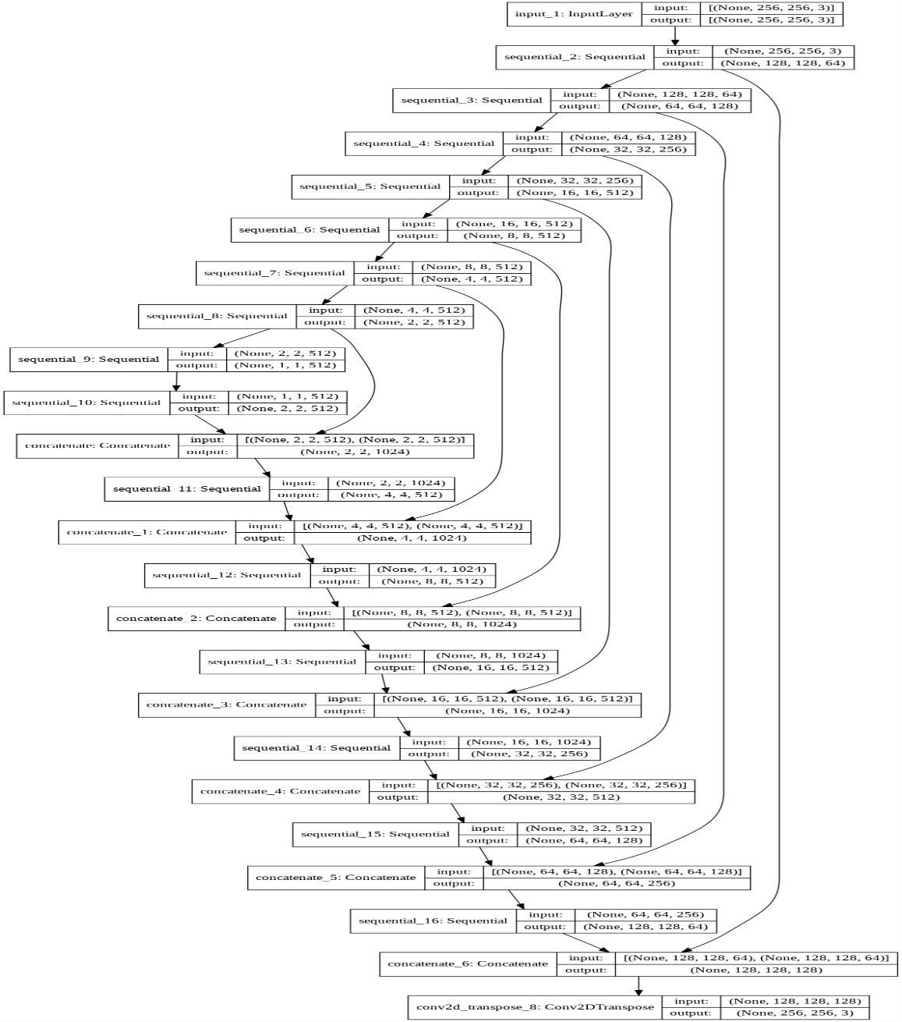

**Discriminator Layout:**

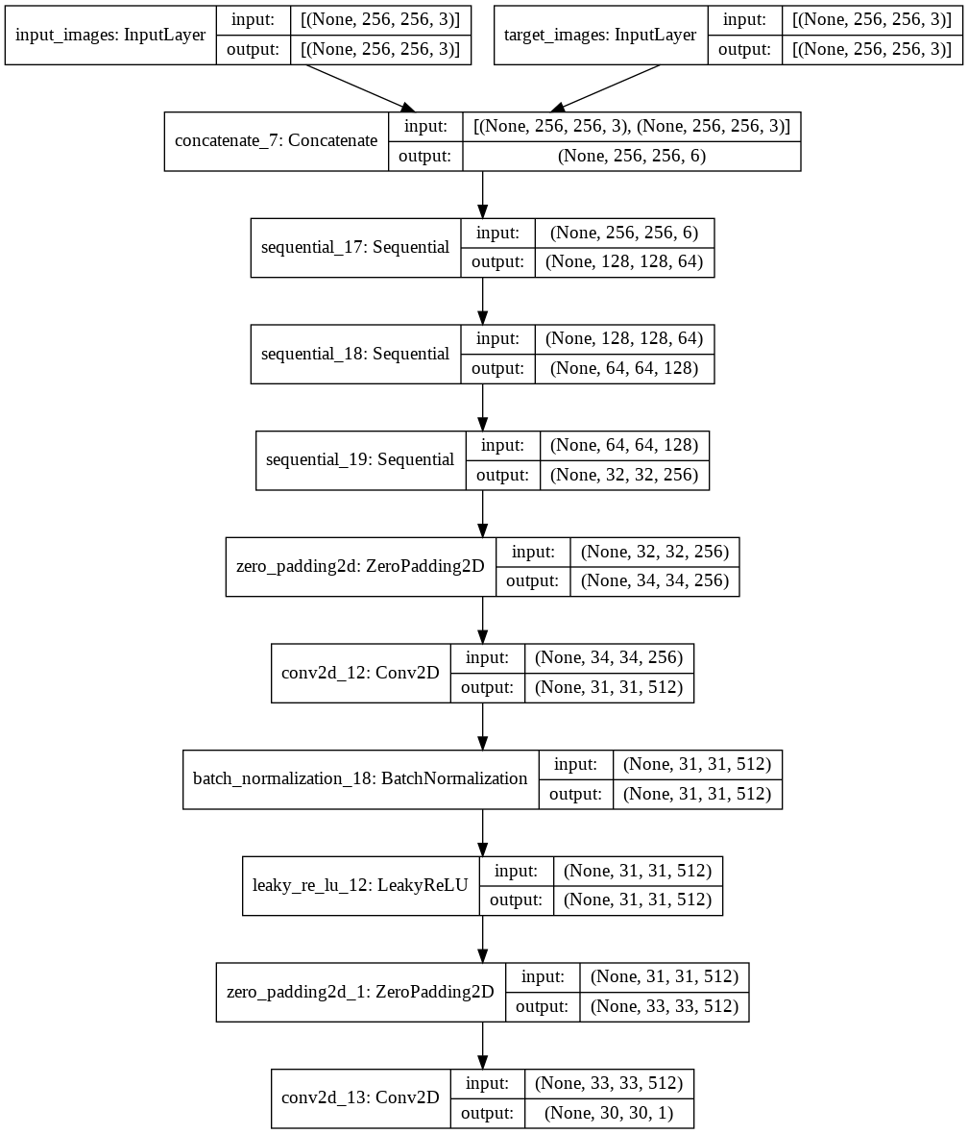

This model of SketchyGAN is a derivative of the previously depicted StyleGAN2 model which has a generator and a discriminator. The roles of these concepts also remain the same. The sequential layer API creates models layer-by-layer. It does not allow to create models with multiple inputs and outputs. The concatenate layer is used to bring together the output from two different input layers. The above two flow charts clearly depict the scenarios.

1. **RESULTS AND DISCUSSIONS**
   * 1. Results of DCGAN on cat dataset

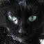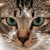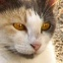

Fig 29. Results of DCGAN on cat dataset

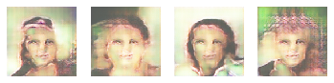

Fig 30. Results of DCGAN on human faces

* + 1. Results of StyleGAN2 on FFHQ dataset

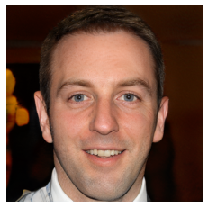

Fig 31. Results of StyleGAN2

**NOTE:** Here, even though the created images are high quality and indistinguishable from the real ones at the first glance, but the background and ears give it away. As it can be clearly seen that in that the background is kind of mutated structure and also the ear size and height are a mismatch.

I came across a Kaggle competition question which read – “Implement a StyleGAN to depict one people with and without glasses”. Upon digging deeper, the process to do this was to modify a single GAN latent vector since that’s what contains the various features. I understood that this latent vector is like a genetic sequence.

After handpicking the images with spectacles/glasses; iterate a single pic through 500 at a batch rate of 10, to find the nominal dimensional range wherein the glasses disappear from the image. The final result is as follows: -

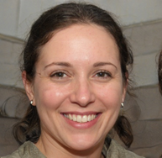 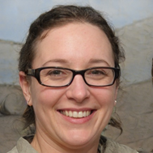

Fig 32. Depicting only one characteristic change i.e the spectacles (done through varying Latent vector)

From the above two images, at closer observation, we can see that there are various differences like change in hair length, a bit of facial feature differences etc. But, all in all at first glance they look like the same person with and without glasses.

8.1.3 Results of StyleGAN2 on SAR images

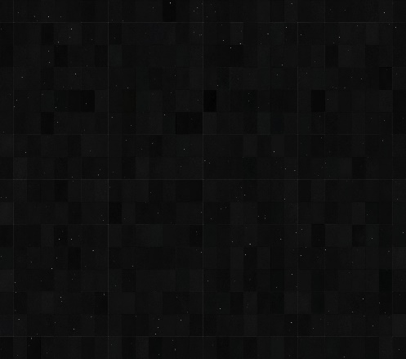

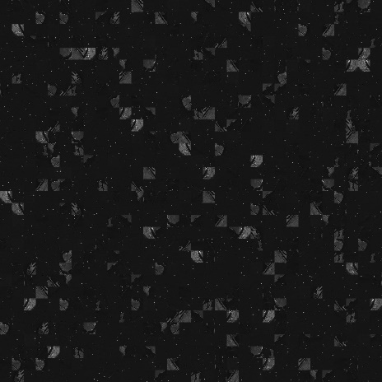

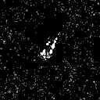

Fig 33 . (a) Result after 10 Iterations (b) . Result after 30 iterations

(c) Result after 60 iterations

* + 1. **Pix2Pix results**

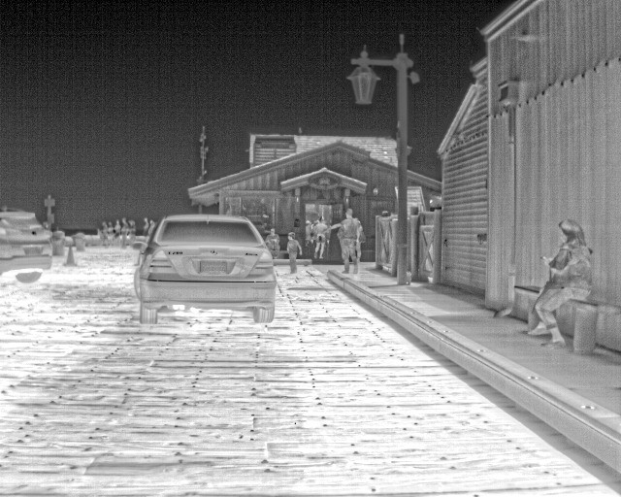

Fig . Original Thermal Image

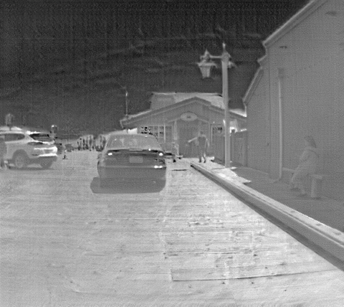

Fig . RGB to Thermal image using Pix2Pix

* 1. **Results and datasets of SketchyGAN on ships dataset**

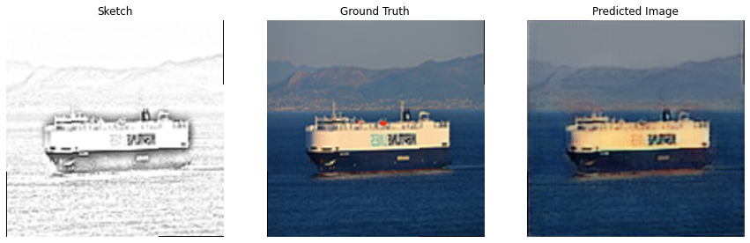

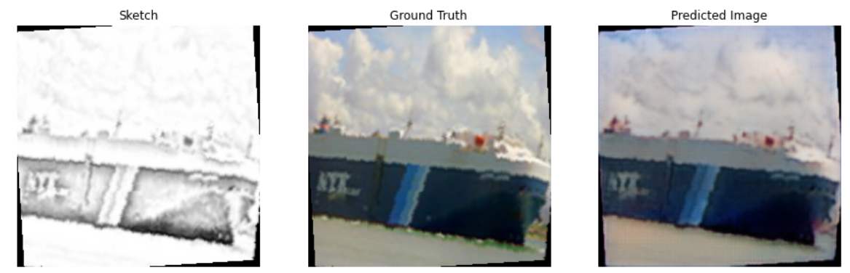

Fig . The above two images show the prediction of ships from its sketches

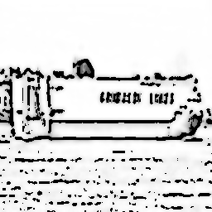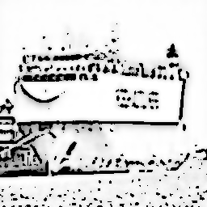

Fig . These represent the crude sketches of ships

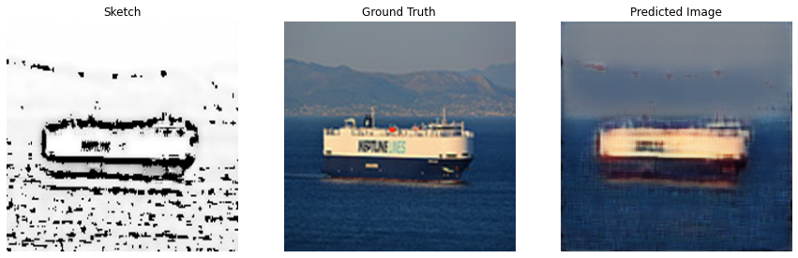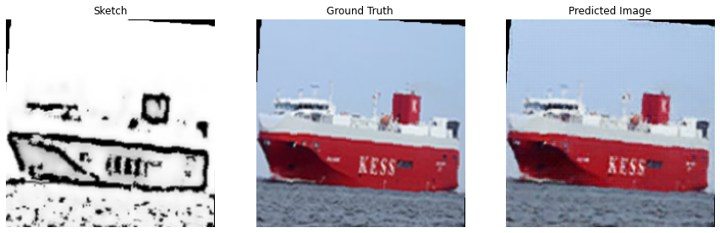

Fig . These images are the results of sketchyGAN from crude sketches

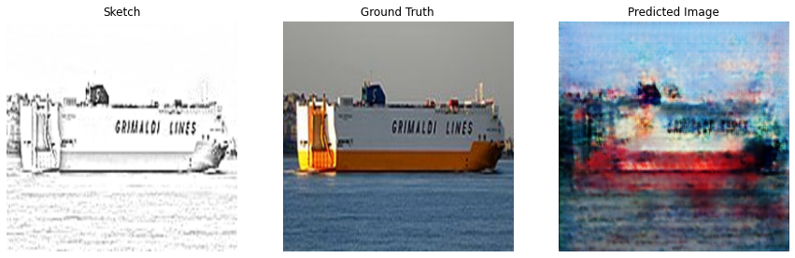

Fig . Image predicted when a random ship sketch is given as input

**8.3 Discussion of the Evaluation metrics**

Evaluation metrics are an essential part of the any ML project because it lets the developer judge as to how good or better is the model developed in comparison to the existing ones. Similarly, for the developed GAN models for various applications needs to be adjudged with evaluation metrics. The most commonly used metrics for GAN images are as follows with the state of art and obtained scores.

1. Inception Score or IS for short, is an objective metric for evaluating the quality of generated images, specifically synthetic images output by generative adversarial network models.
2. The Fréchet Inception Distance score, or FID for short, is a metric that calculates the distance between feature vectors calculated for real and generated images. [Lower the FID score, better the model].

|  |  |  |
| --- | --- | --- |
|  | State of art | Obtained score |
| IS | 11.43 | 9.46 |
| FID | 2.2 | 3.15 |

The following are the evaluation metrics of sketchyGAN for the marvel sketch to ship dataset: -

|  |  |
| --- | --- |
| total mean absolute error on the testing dataset | 2.079622507095337 |
| FID score: | 3.85678 |
| Inception Score: mean | 10.51256 |
| Standard deviation | 0.089195 |

The total mean absolute error (MAE) refers to the magnitude of difference between the prediction of an observation and the true value of that observation. MAE takes the average of absolute errors for a group of predictions and observations as a measurement of the magnitude of errors for the entire group. In short, the lesser the MAE, the better the model. Standard deviation is a number that describes how spread out the values are. A low standard deviation means that most of the numbers are close to the mean (average) value. The more the points nearer to the mean , the lower the standard deviation and the better the model.

1. **SUMMARY**

This project has put worth various ways in which SAR generation costs can be cut down and at the same time the quality of images is not compromised. Though the second half of the prior point needs to be administered in future scope. This concept of SAR generation has not been delved into a lot in recent times and some real progress has been made with working on such an untouched research topic. Adding to this, many image translation techniques have been implemented on SAR images but without huge success.

On the whole, even a second issue of thermal image generation was looked into and a simple yet effective method of RGB to Thermal image conversion was proposed. Even though this idea was already preexisting, I implemented it just for the sake of using Pix2Pix with CGAN.

Moving towards the third topic of concentration in the “GAN applications”: SketchyGAN. In this concept, the main motive is to synthesize real life images from raw sketches. Even though, SketchyGAN has been researched but the main research gap that remains is the availability of datasets which have both sketches combined with the corresponding real life images. Thus, in this project, the main intention was to produce ship images from its sketches. Due to the inavailaibility of the datasets for the same; the datasets ahd to be created. Firstly, Pix2Pix was used to create sketches from Marvel dataset but since they looked very accurate and the algorithm could easily predict it, further the same sketches were made into crude sketches using cartoon GAN. These crude images were used as inputs and the final image set in the results section clearly depicts how the machine has learned from the previous train sets and can depict ships which are at least distinguishable as ships.

## References

1. A. Love, "In memory of Carl A. Wiley," IEEE Antennas and Propagation Society Newsletter, vol. 27, pp. 17-18, 1985.

2. TerraSAR-X – Germany’s radar eye in space. Available online: <https://www.dlr.de/dlr/en/desktopdefault>. (accessed on 18th May 2018).

3. TanDEM-X - the Earth in three dimensions. Available online https://www.dlr.de/dlr/en/desktopdefault. (accessed on 18th May 2018).

4. Zhang F, et al., “Multiple Mode SAR Raw Data Simulation and Parallel Acceleration for Gaofen-3 Mission,” IEEE Journal of Selected Topics in Applied Earth Observations and Remote Sensing, vol. 11, pp. 2115-2126, 2018.

5. I. Goodfellow, J. Pouget-Abadie, M. Mirza, B. Xu, D. Warde-Farley, S. Ozair, et al., "Generative adversarial nets," in Advances in neural information processing systems, 2014, pp. 2672-2680.

6. Ian Goodfellow, Jean Pouget-Abadie, Mehdi Mirza, Bing Xu, David Warde-Farley, Sherjil Ozair, Aaron Courville, and Yoshua Bengio. Generative adversarial networks. In NIPS, 2014.

7. A. Radford, L. Metz, and S. Chintala. Unsupervised representation learning with deep convolutional generative adversarial networks. In ICLR, 2015

8. I. Goodfellow, J. Pouget-Abadie, M. Mirza, B. Xu, D. Warde Farley, S. Ozair, A. Courville, and Y. Bengio. Generative adversarial networks. In NeurIPS, 2014.

9. K. Roth, A. Lucchi, S. Nowozin, and T. Hofmann. Stabilizing training of generative adversarial networks through regularization, In NeurIPS, 2017.

10. D. Kingma and J. Ba. Adam: A method for stochastic optimization. In ICLR, 2015

11. J.-Y. Zhu, T. Park, P. Isola, and A. A. Efros. Unpaired image-toimage translation using cycle-consistent adversarial networks. In ICCV, 2017

12. H. Kim, P. Garrido, A. Tewari, W. Xu, J. Thies, M. Niessner, P. Perez, C. Richardt, M. Zollh ´ ofer, and C. Theobalt. Deep video ¨ portraits. TOG, 2018

13. A. v. d. Oord, S. Dieleman, H. Zen, K. Simonyan, O. Vinyals, A. Graves, N. Kalchbrenner, A. Senior, and K. Kavukcuoglu. WaveNet: A generative model for raw audio. arXiv preprint arXiv:1609.03499, 2016.

14. A. Van den Oord, N. Kalchbrenner, L. Espeholt, O. Vinyals, A. Graves, et al. Conditional image generation with PixelCNN decoders. In NeurIPS, 2016.

15. T.-C. Wang, M.-Y. Liu, J.-Y. Zhu, A. Tao, J. Kautz, and B. Catanzaro. High-resolution image synthesis and semantic manipulation with conditional GANs. In CVPR, 2018.

16. X. Huang, M.-Y. Liu, S. Belongie, and J. Kautz. Multimodal unsupervised image-to-image translation. ECCV, 2018

17. N. Merkle, S. Auer, R. Müller, and P. Reinartz, "Exploring the Potential of Conditional Adversarial Networks for Optical and SAR Image Matching," IEEE Journal of Selected Topics in Applied Earth Observations and Remote Sensing, 2018.

18. C. Li and M. Wand, "Precomputed real-time texture synthesis with Markovian generative adversarial networks," in European Conference on Computer Vision, 2016

19. Zhang H, et al., “Stackgan: Text to photo-realistic image synthesis with stacked generative adversarial networks,” Proceedings of the IEEE International Conference on Computer Vision, pp. 5907-5915, 2017.

20. J.-Y. Zhu, P. Krähenbühl, E. Shechtman, and A. A. Efros, "Generative visual manipulation on the natural image manifold," in European Conference on Computer Vision, 2016, pp. 597-613.

21. Ming-Yu Liu, Xun Huang, Jiahui Yu, Ting-Chun Wang, Arun Mallya-“ Generative Adversarial Networks for Image and Video Synthesis: Algorithms and Applications”, arXiv:2008.02793v1 [cs.CV] 6 Aug 2020

22. Lichao Zhang, Abel Gonzalez-Garcia, Joost van de Weijer, Martin Danelljan, and Fahad Shahbaz Khan –“ Synthetic data generation for end-to-end thermal infrared tracking”, arXiv:1806.01013v2 [cs.CV] 26 Sep 2018